Discover Varanasi with INTRO TRAVELS INDIA
Varanasi, also known as Kashi or Banaras, is one of the oldest living cities in the world and the spiritual capital of India. Situated on the sacred banks of the River Ganga in Uttar Pradesh, Varanasi is famous for its ancient temples, spiritual atmosphere, mesmerizing Ganga Aarti, holy ghats, cultural heritage, and traditional music and art.
Whether you are planning a spiritual journey, cultural exploration, heritage tour, or photography trip, Varanasi offers a deeply memorable and soulful experience.

Why Visit Varanasi?
- One of the world’s oldest living cities
- Sacred River Ganga & spiritual significance
- Famous Ganga Aarti ceremonies
- Ancient temples & ghats
- Rich Hindu culture & traditions
- Spiritual and peaceful atmosphere
- Traditional music, silk & handicrafts
- Perfect destination for heritage & spiritual tourism

Top Tourist Attractions in Varanasi
1. Dashashwamedh Ghat
The most famous ghat in Varanasi known for the grand evening Ganga Aarti.
Highlights:
- Spiritual rituals
- Evening Ganga Aarti
- Boat rides on River Ganga
- Cultural atmosphere
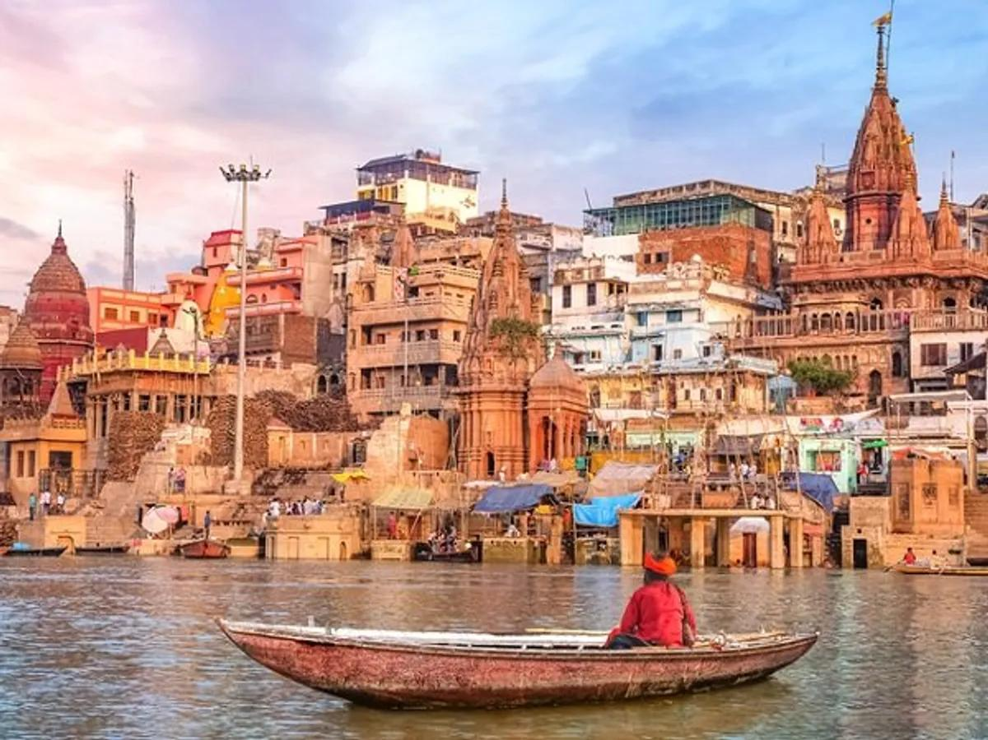
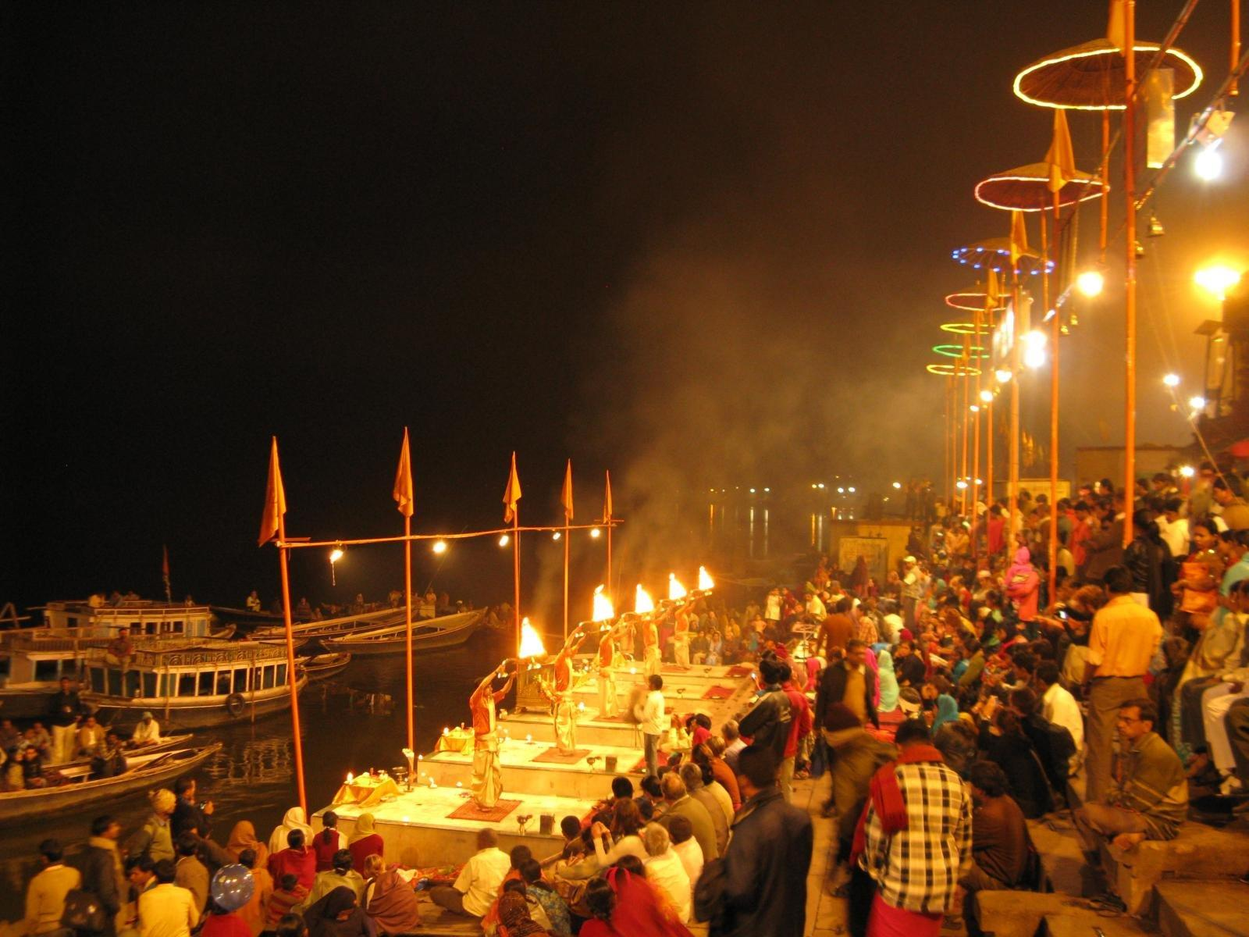
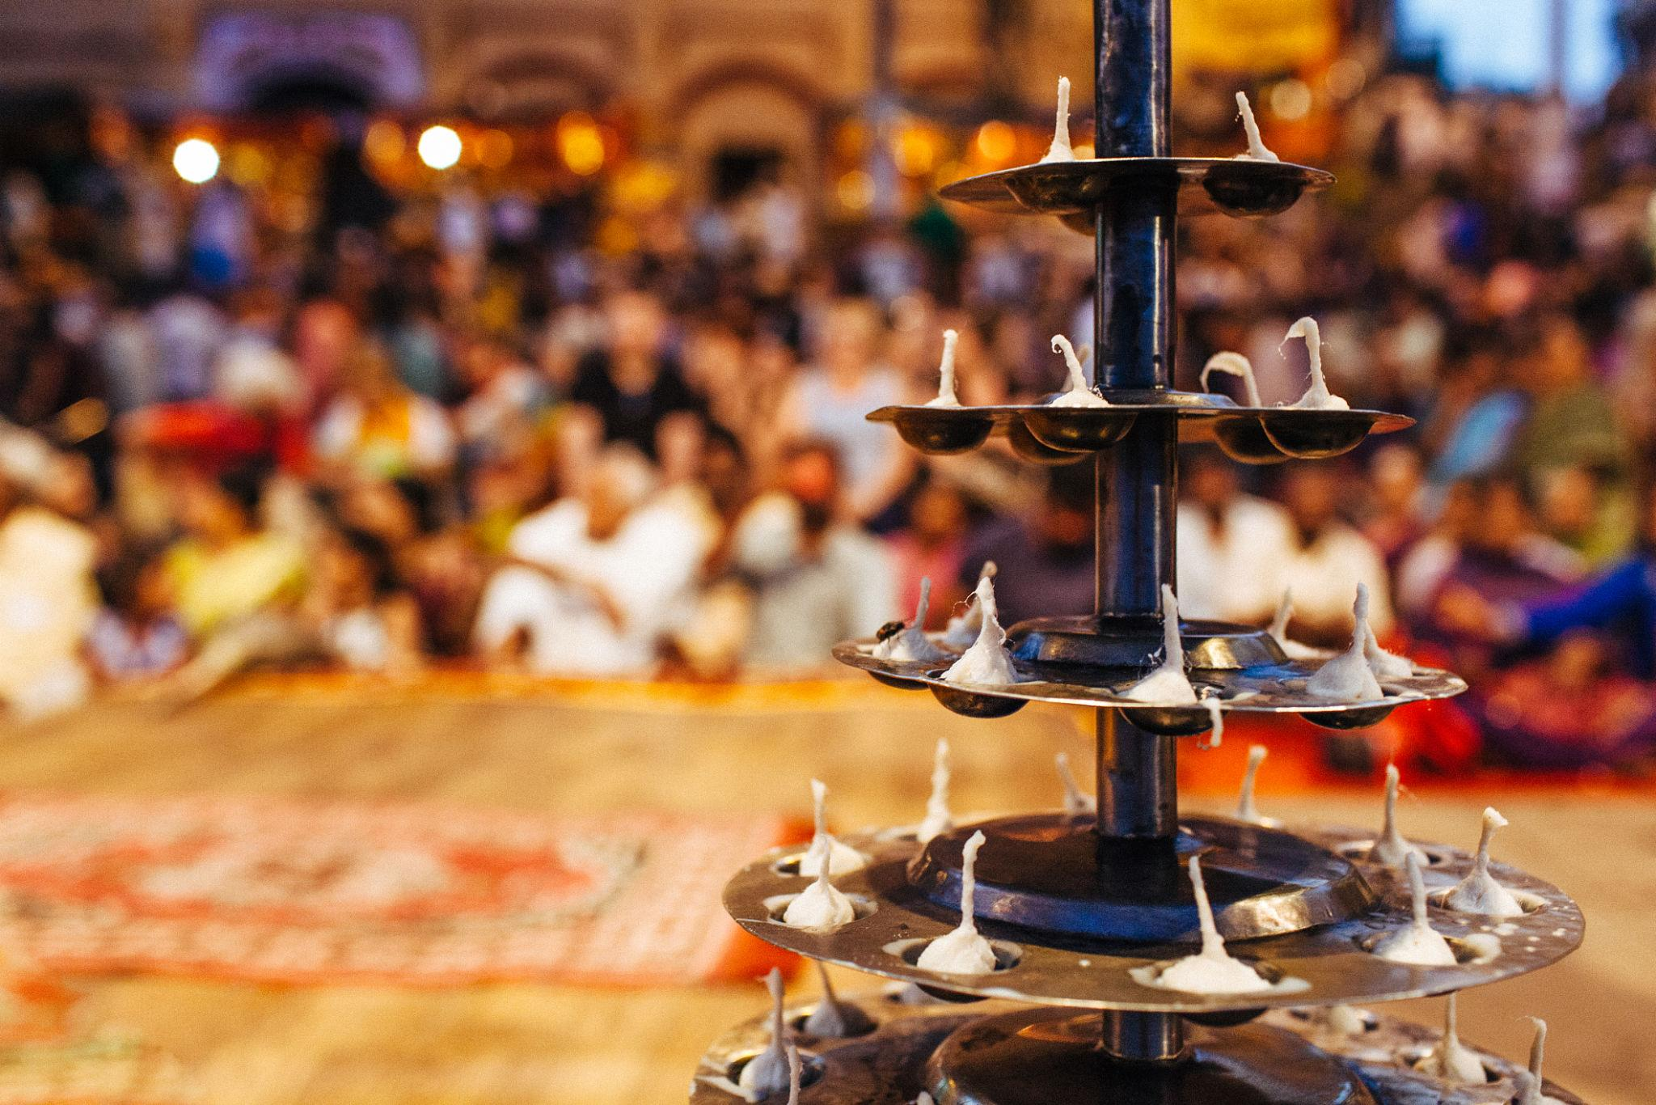
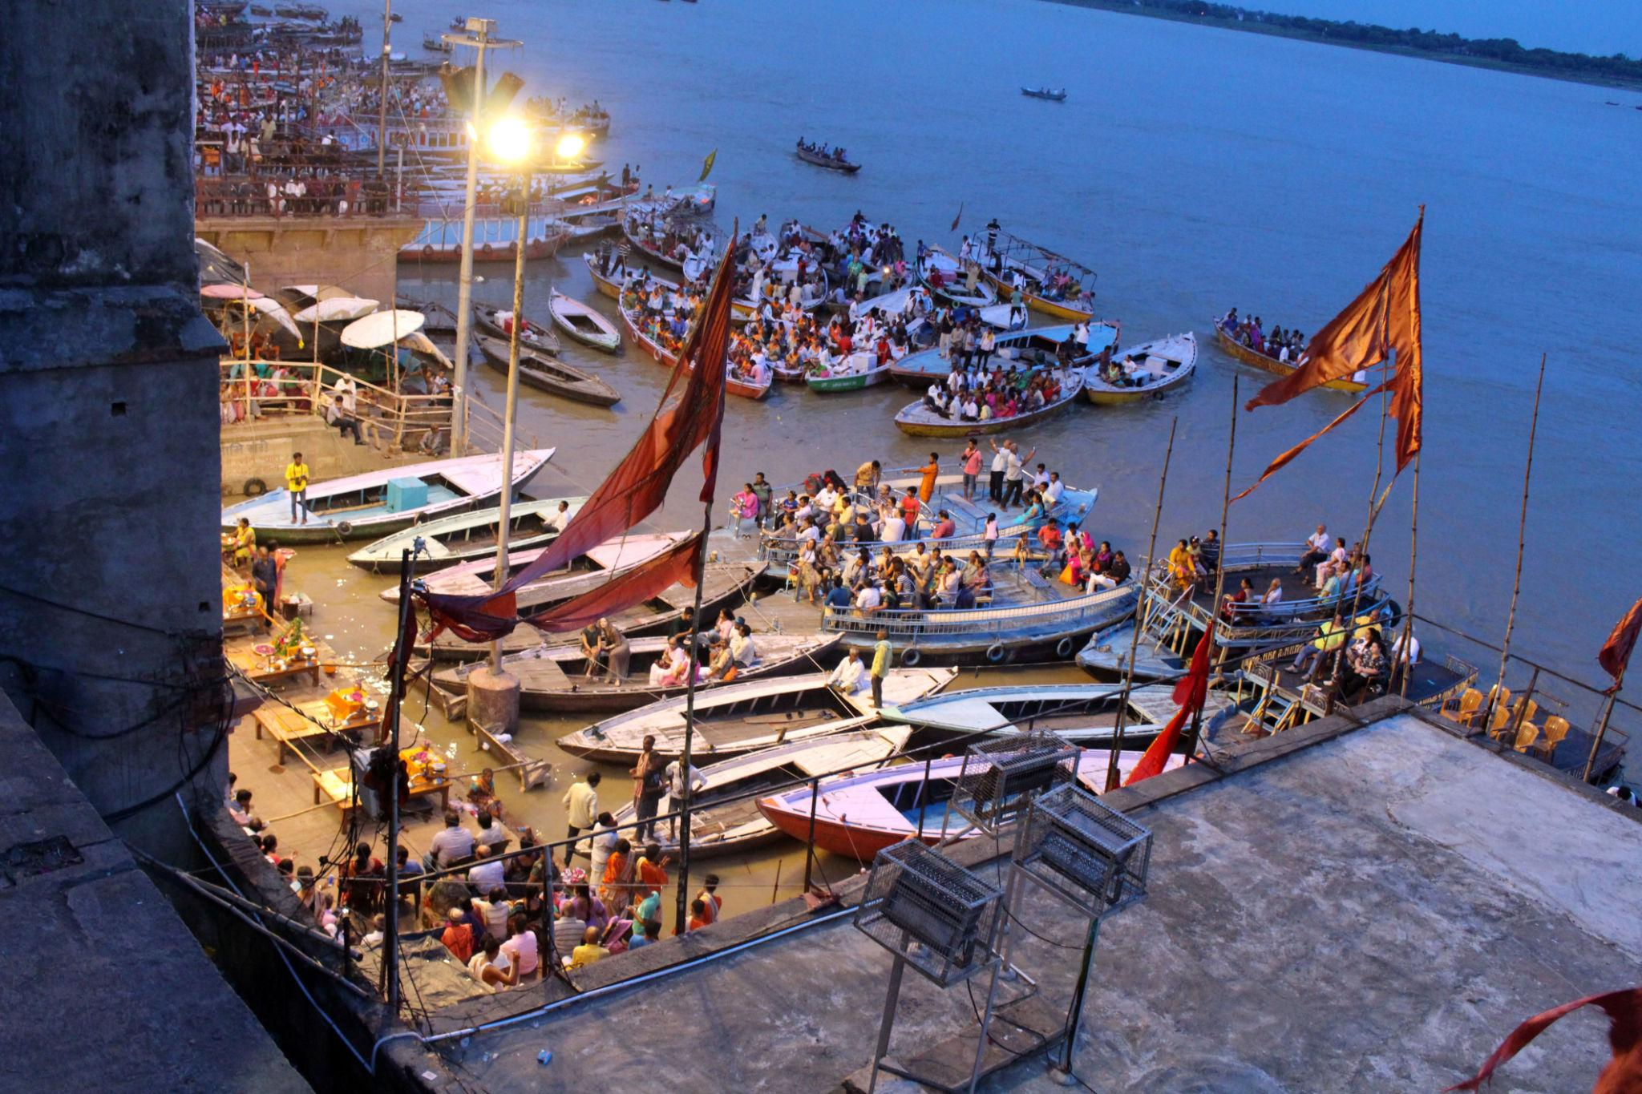
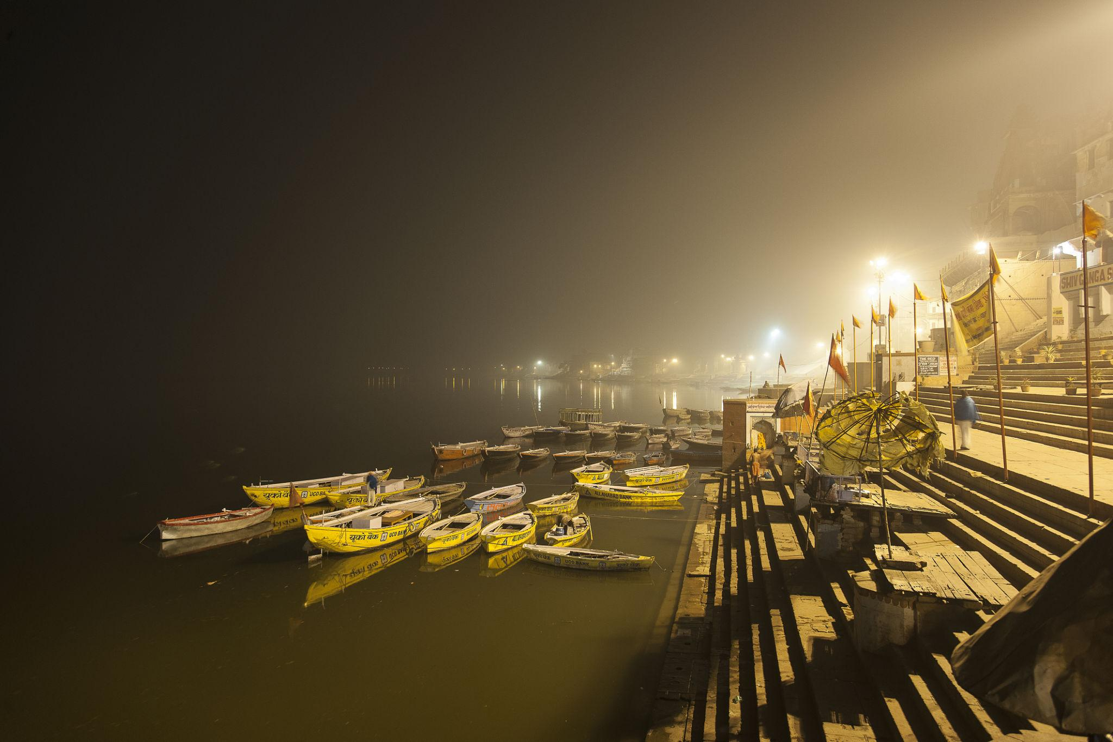
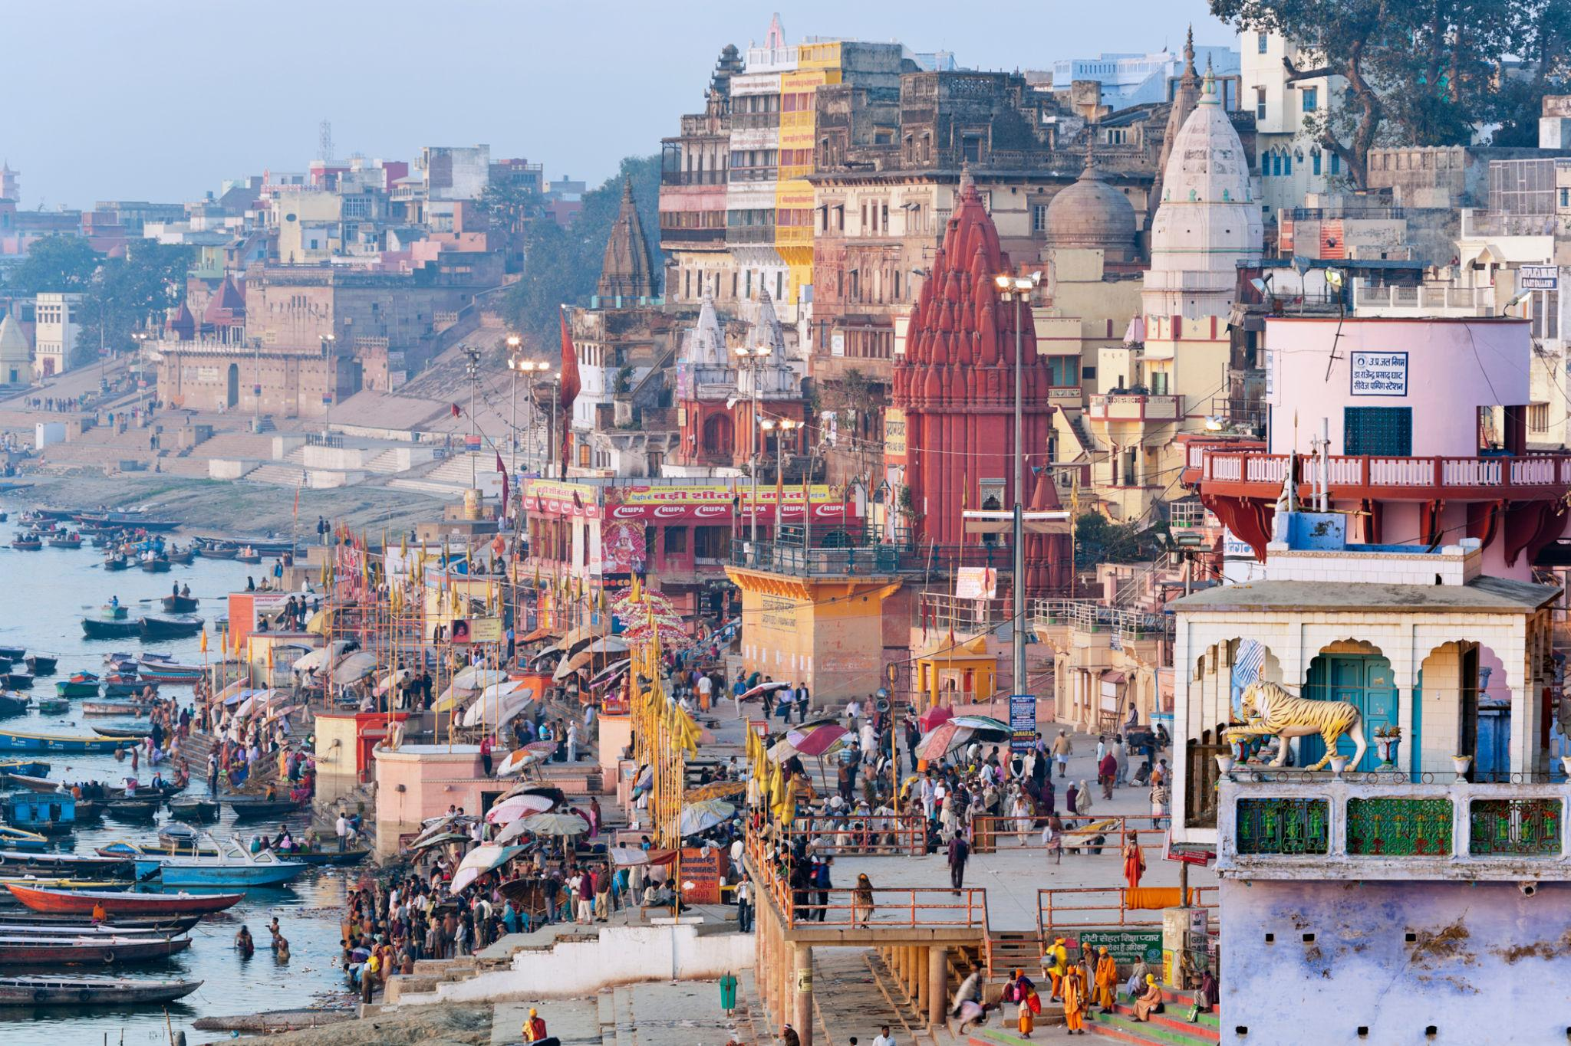
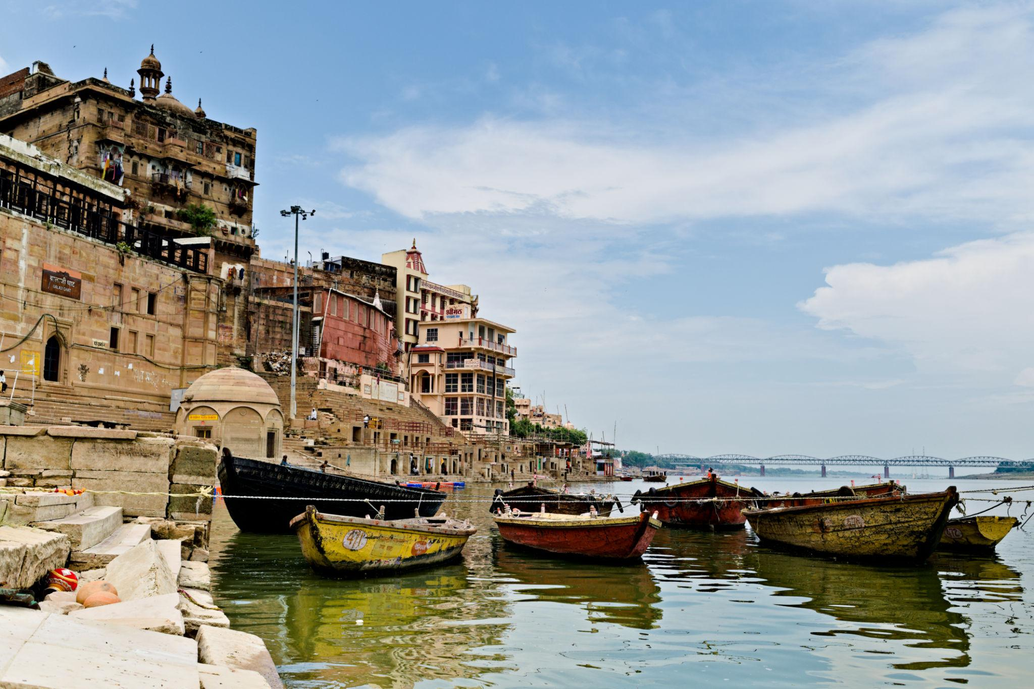

2. Kashi Vishwanath Temple
One of the most sacred Hindu temples dedicated to Lord Shiva.
Known for:
- Spiritual importance
- Gold-plated temple structure
- Pilgrimage significance
- Ancient religious traditions
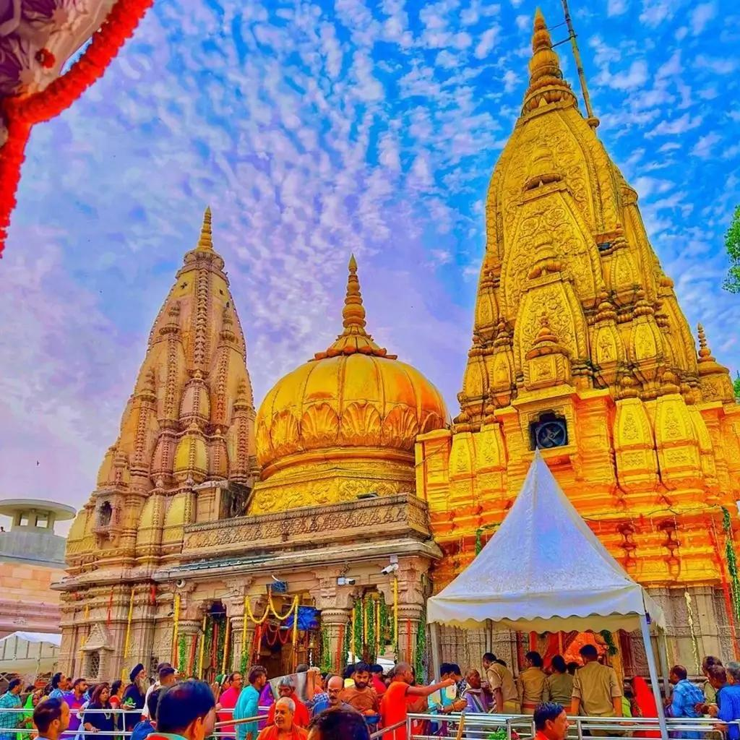
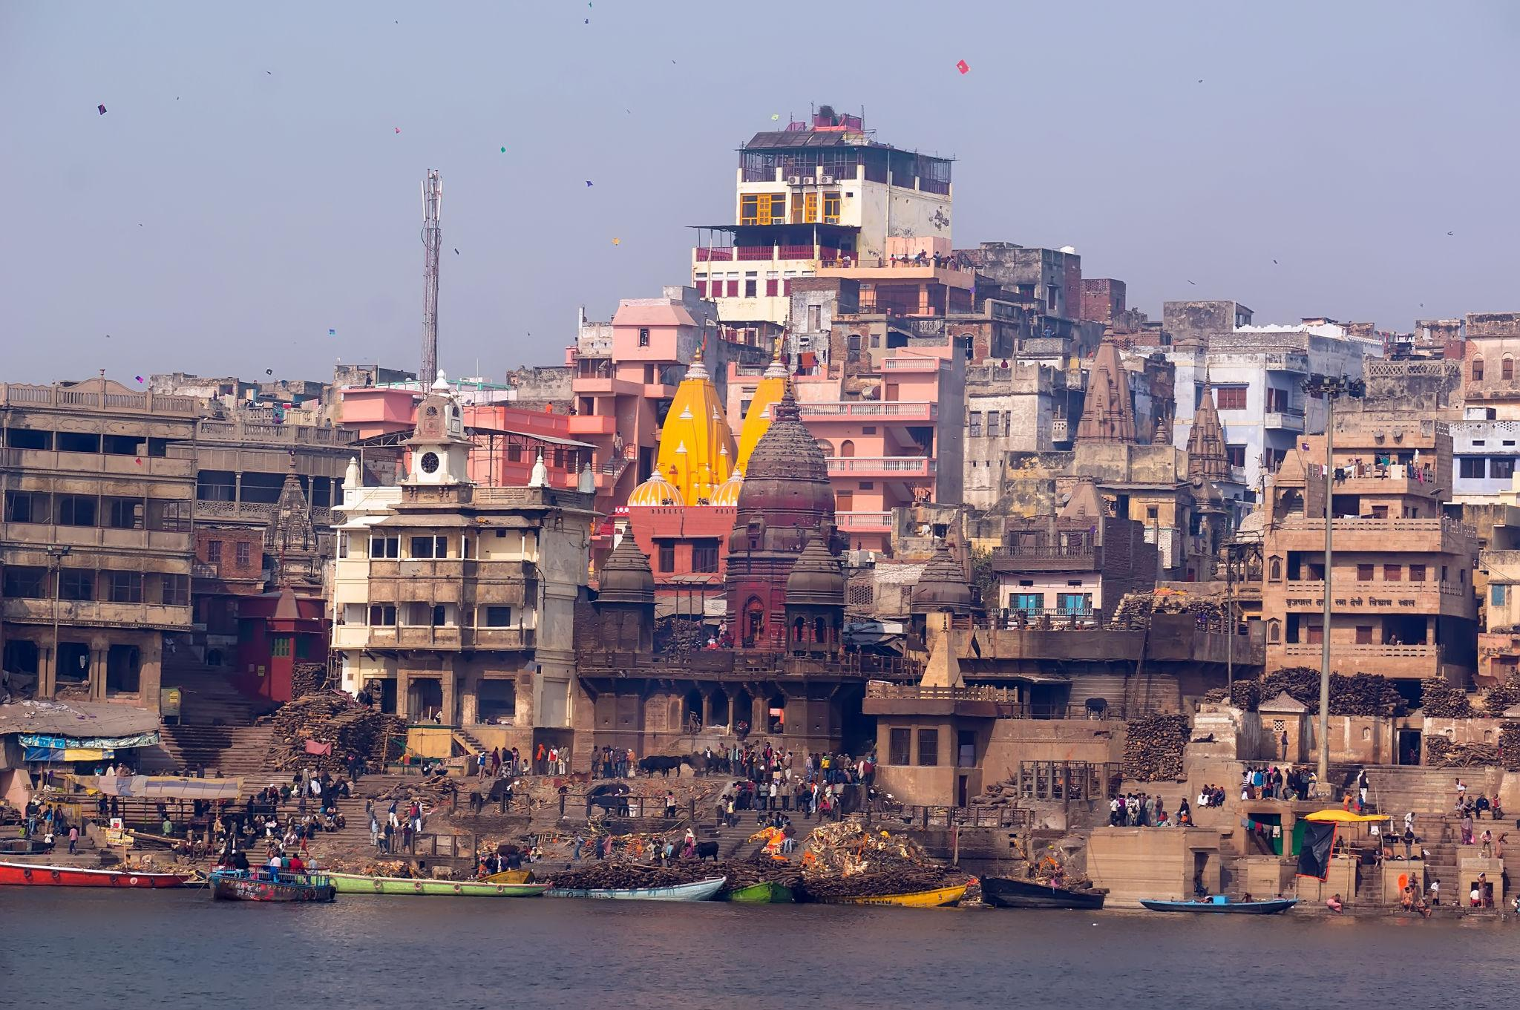
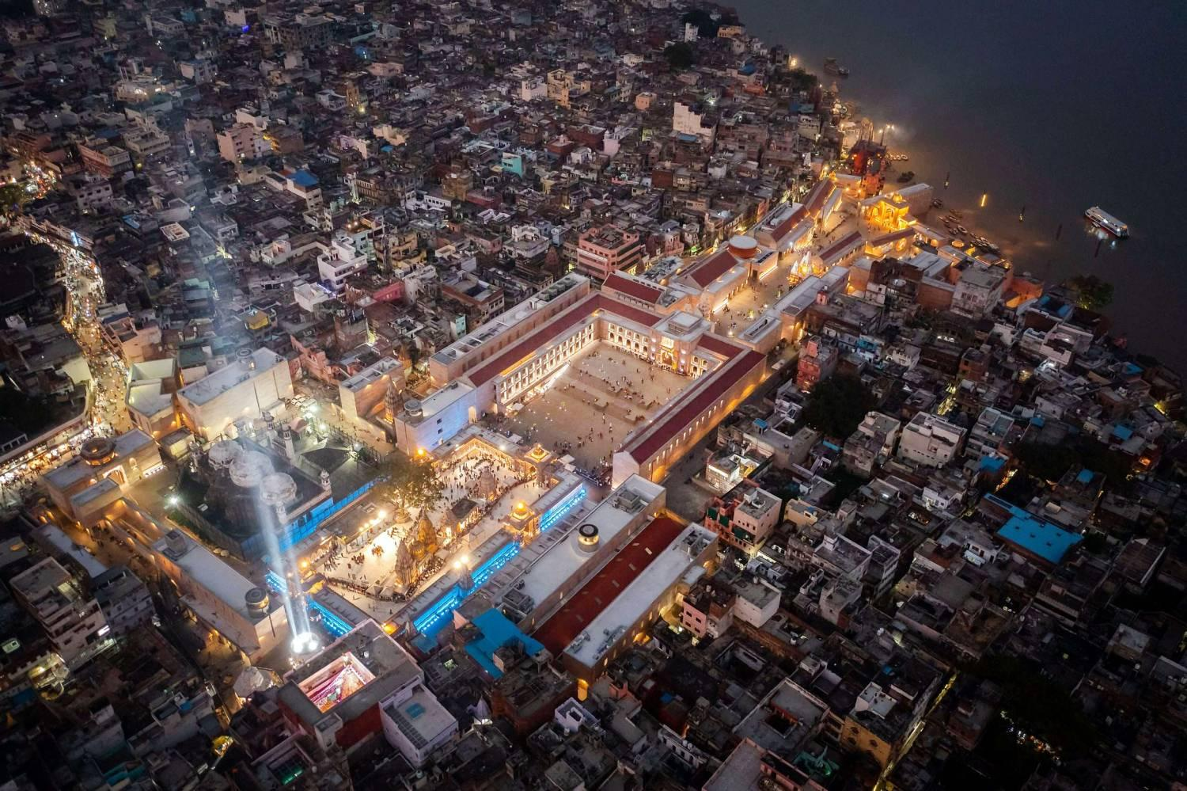
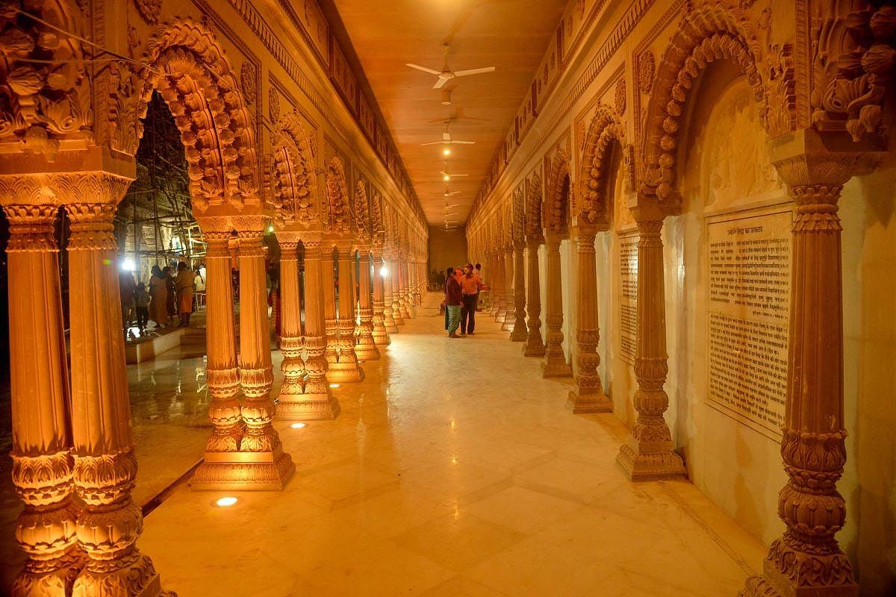
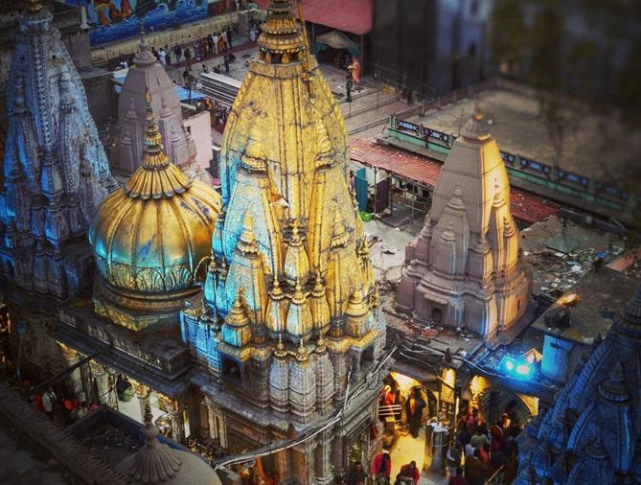
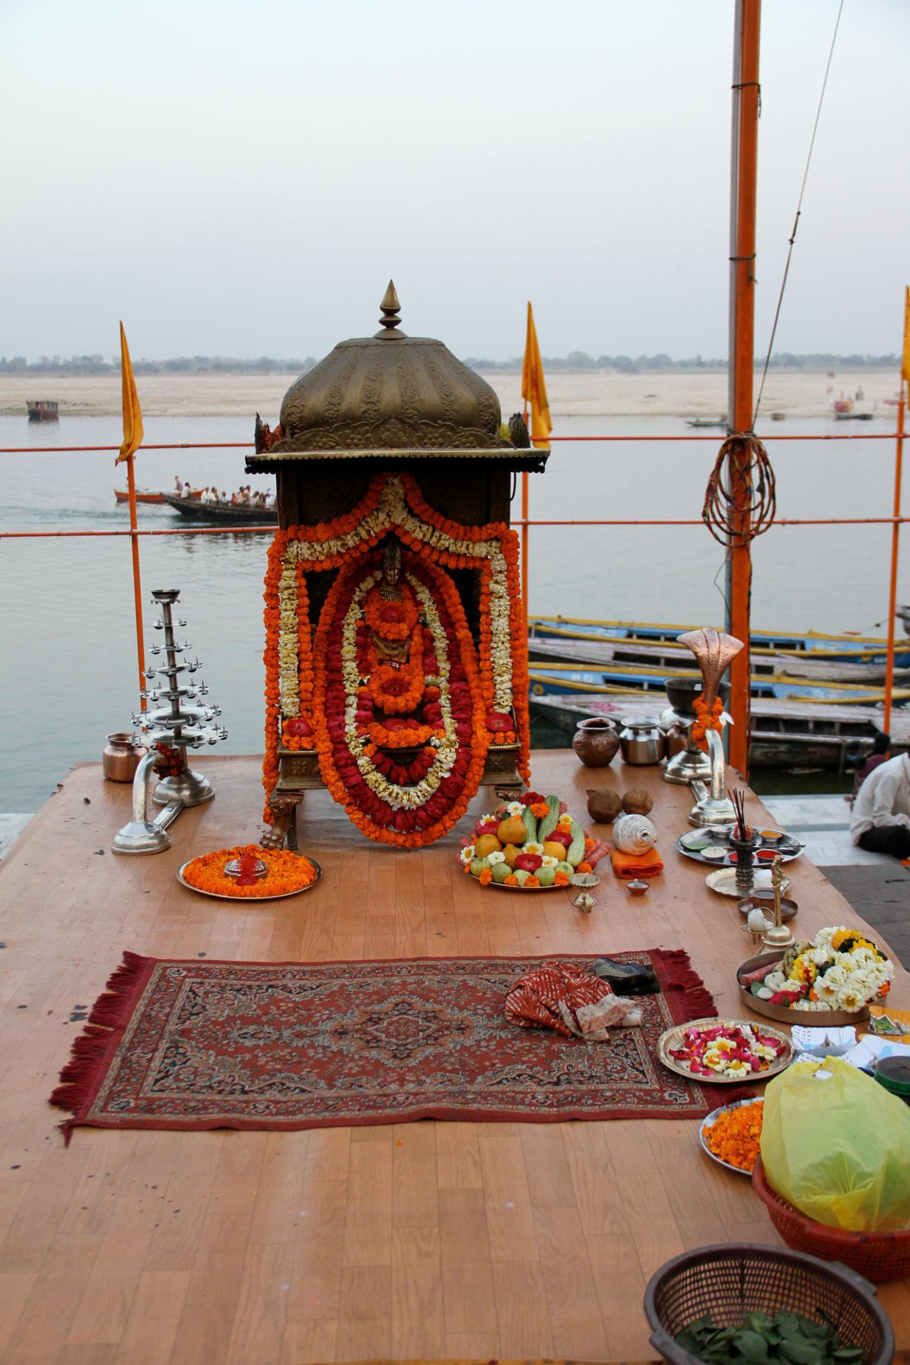
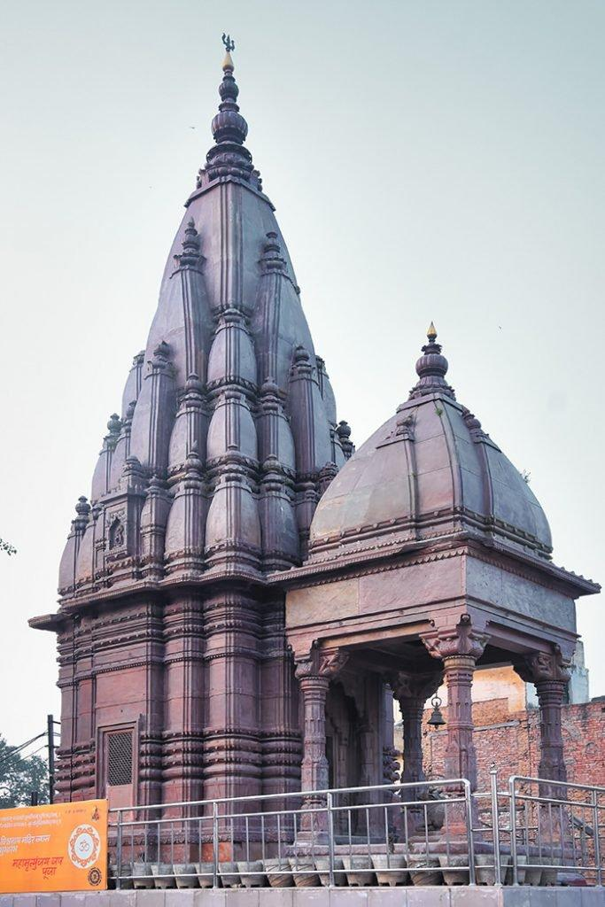

3. Assi Ghat
A peaceful and popular riverside ghat known for yoga, meditation, and sunrise views.
Best experiences:
- Morning boat rides
- Yoga sessions
- Riverside cafés
- Cultural performances
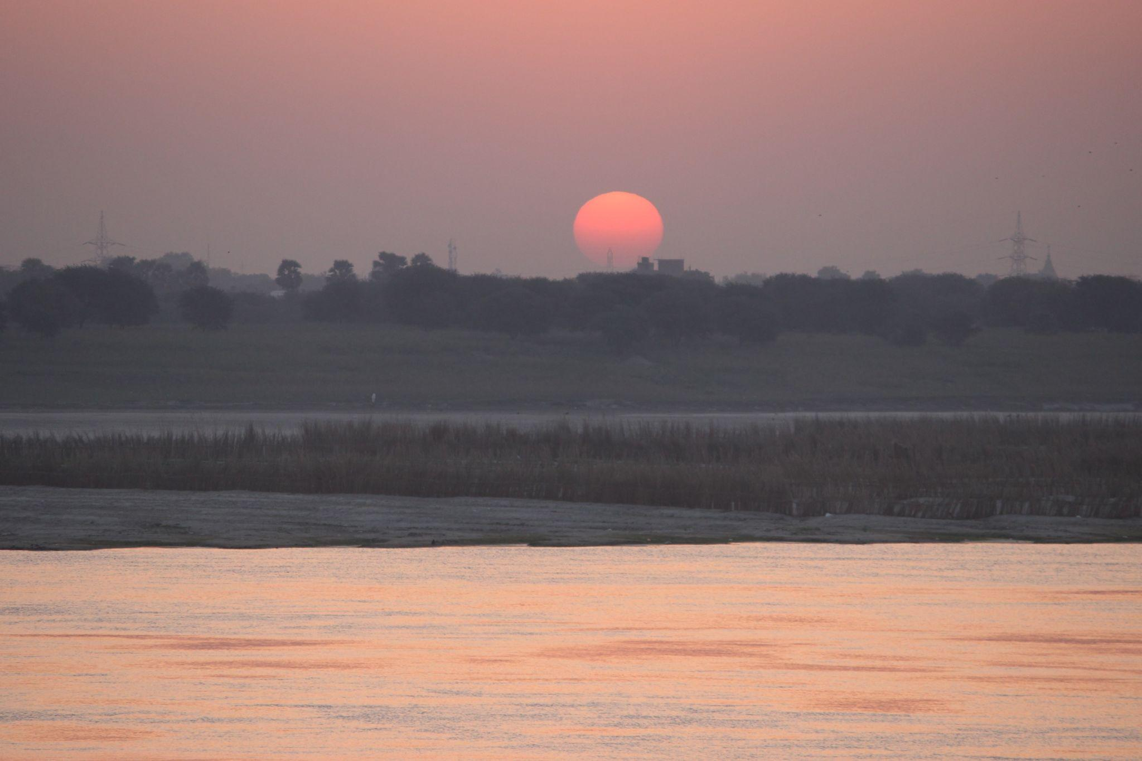
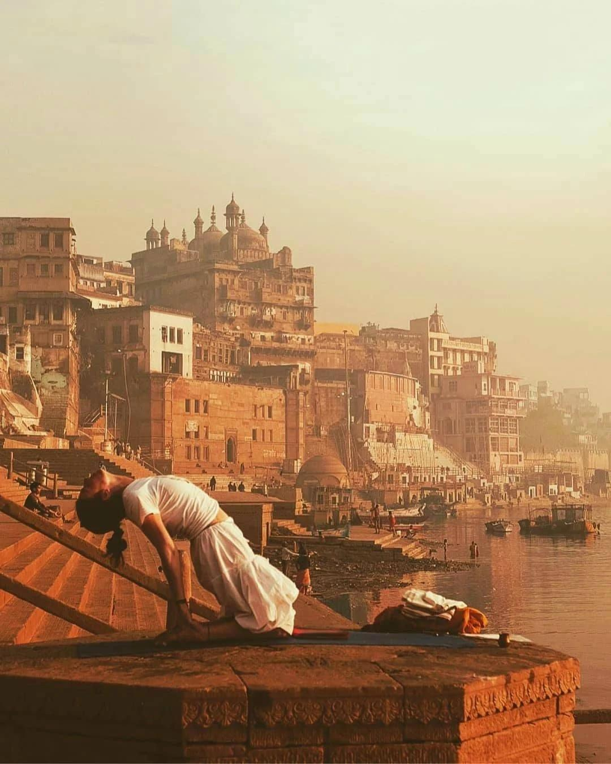
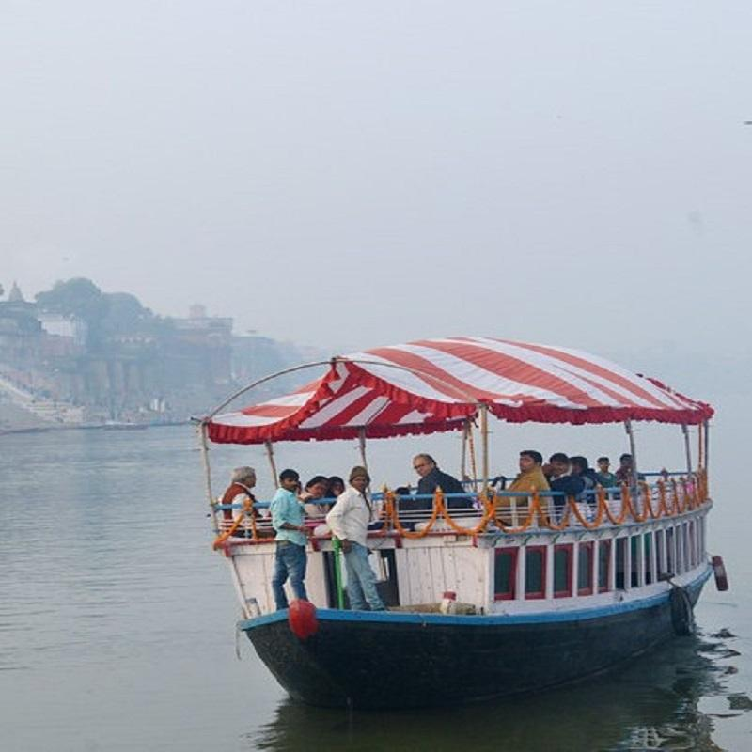
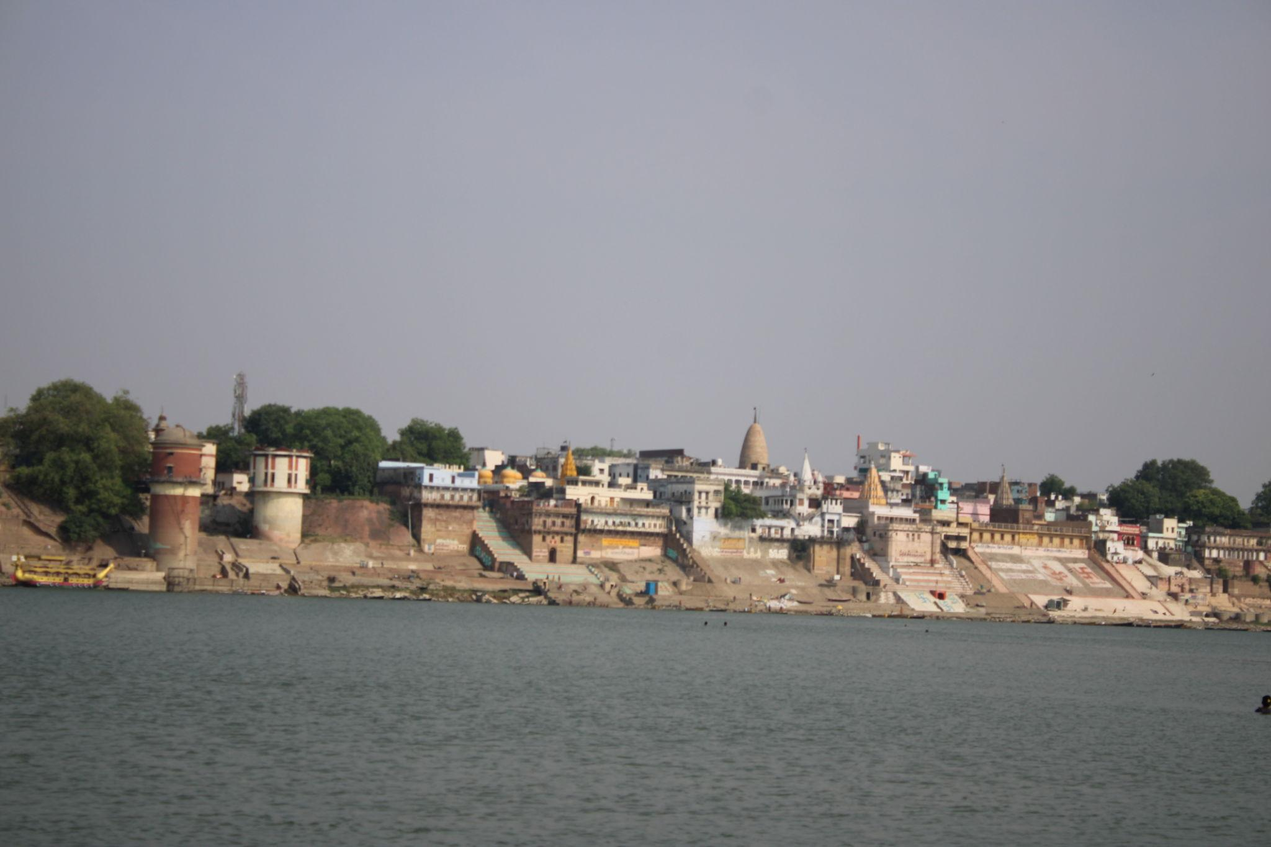

4. Sarnath
A major Buddhist pilgrimage site where Lord Buddha gave his first sermon.
Top attractions:
- Dhamek Stupa
- Buddhist temples
- Archaeological Museum
- Peaceful gardens
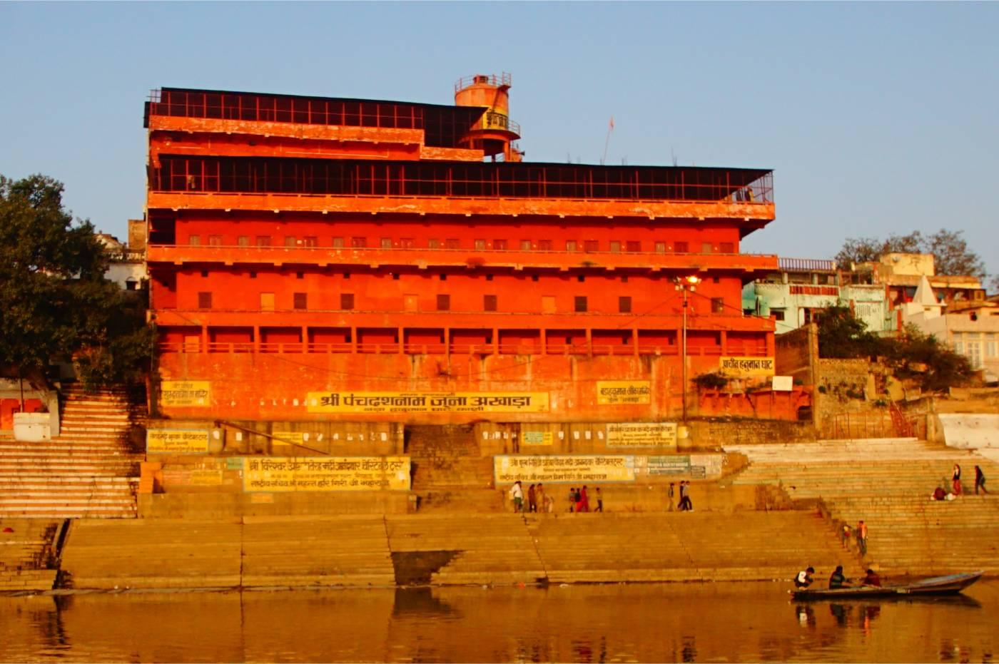
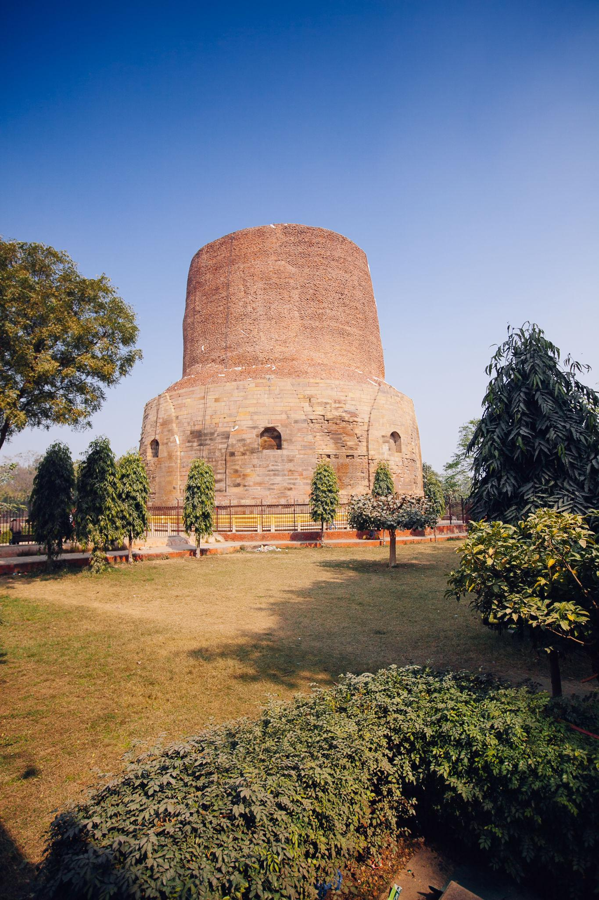
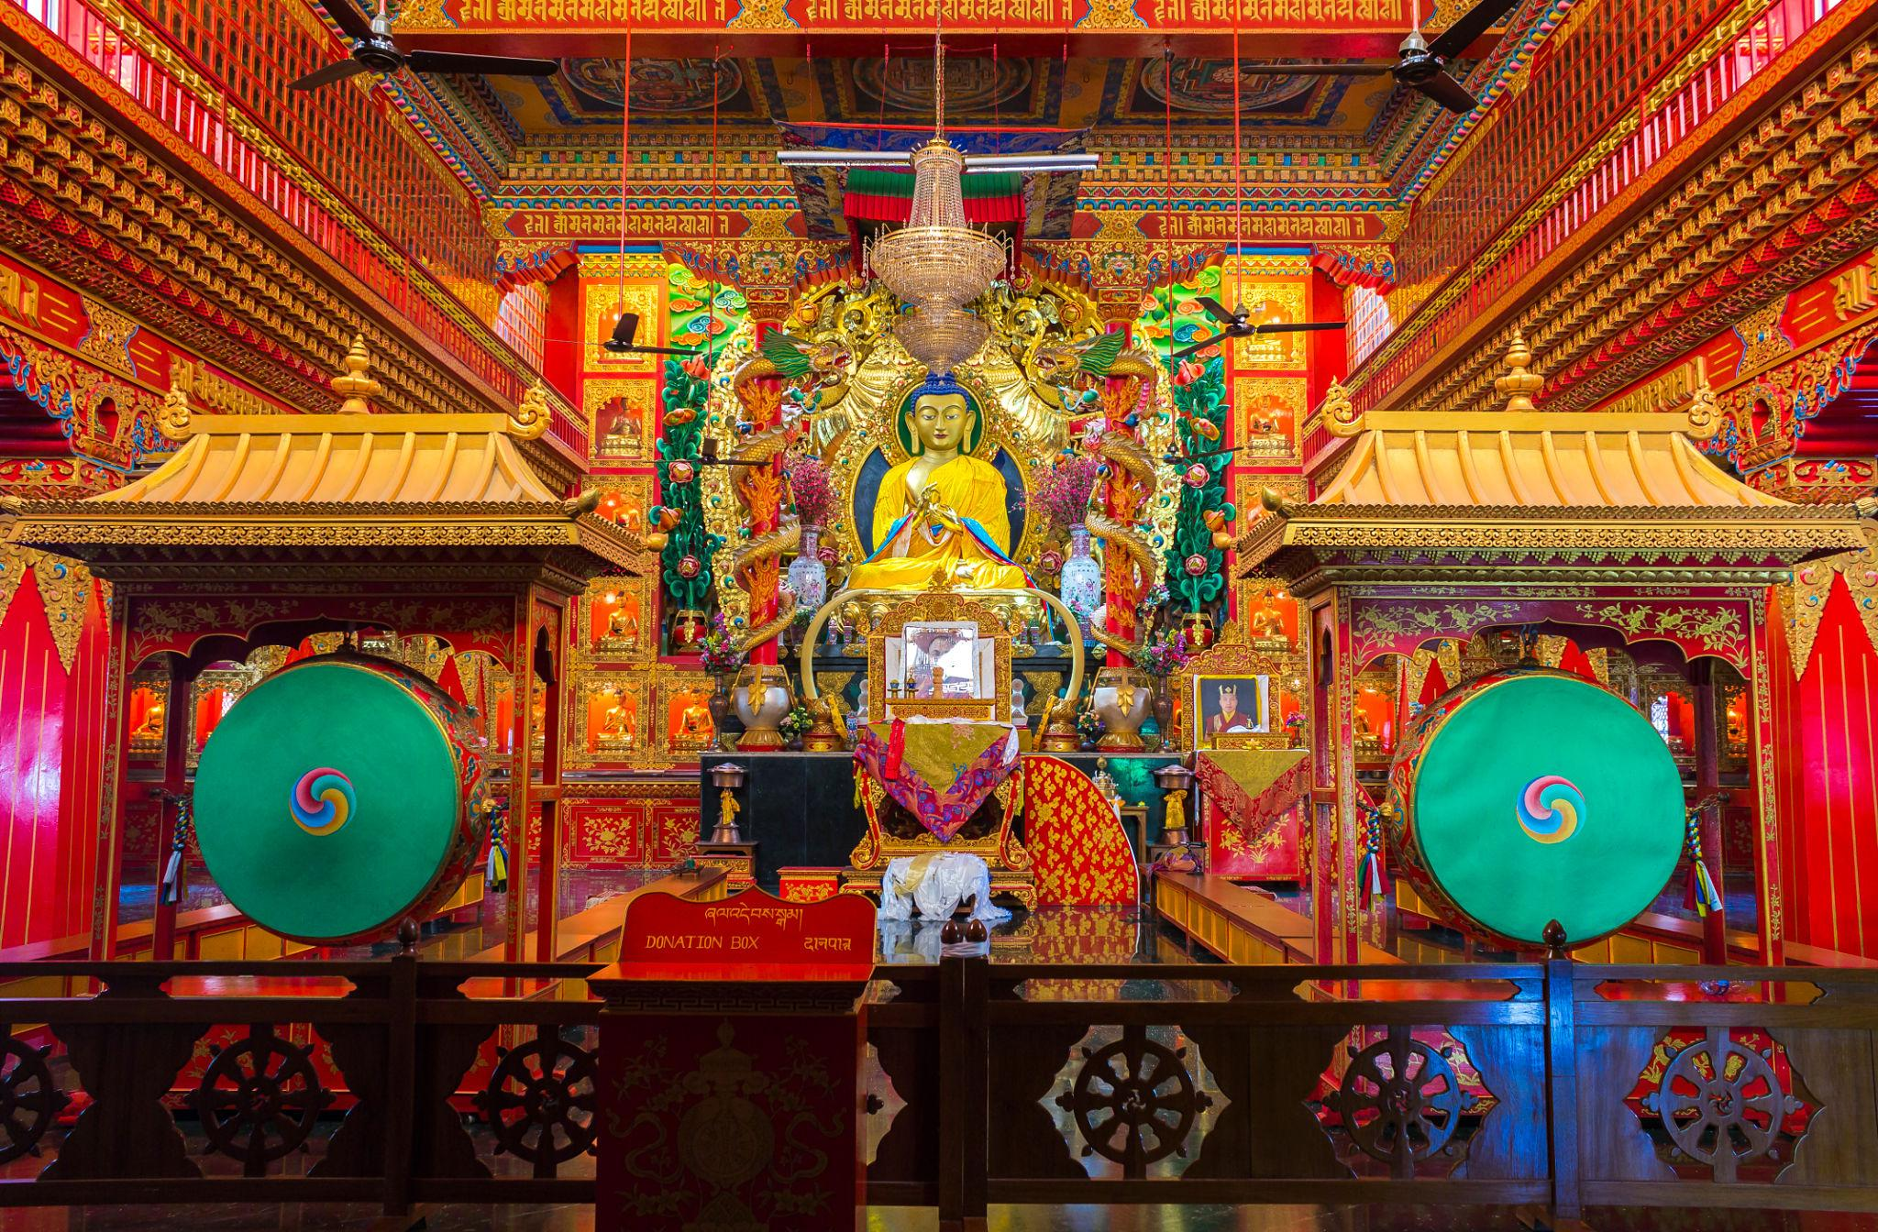
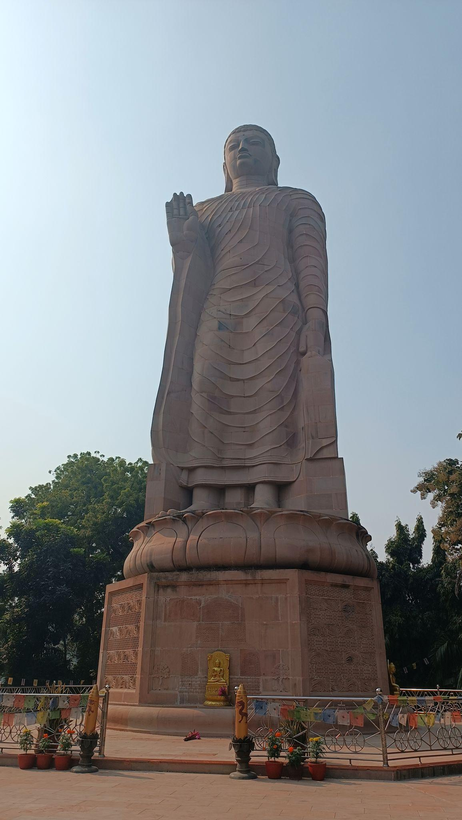
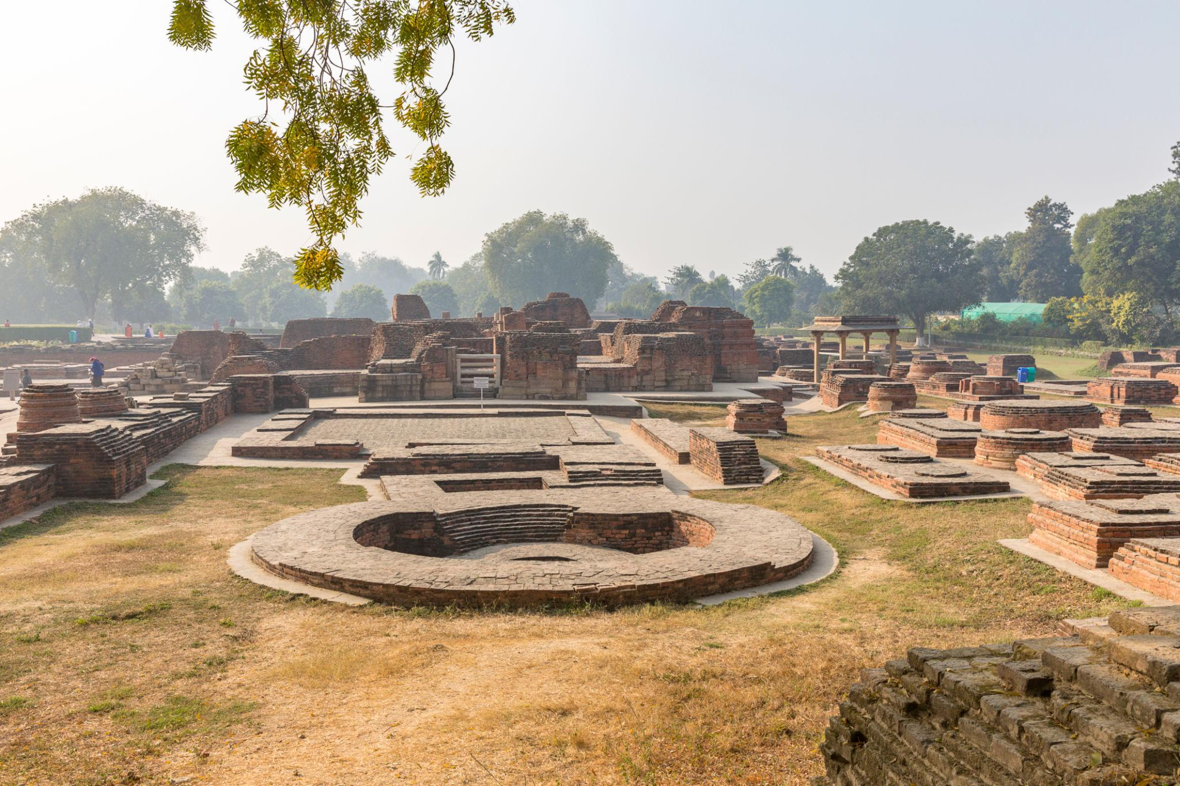

5. Ramnagar Fort
A historic fort located on the eastern bank of the Ganga River.
Highlights:
- Royal museum
- Vintage cars
- Historic architecture
- Riverfront views
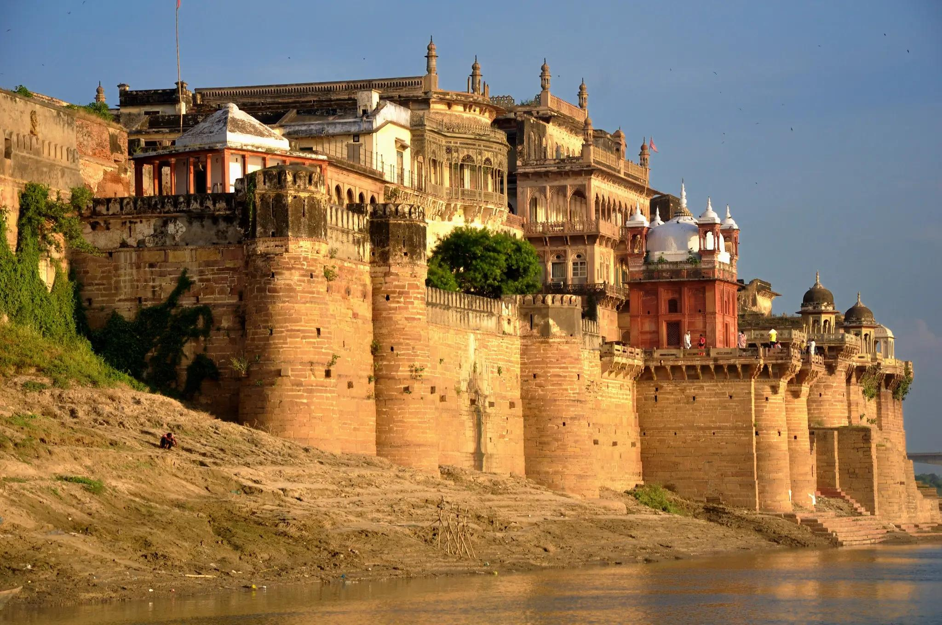
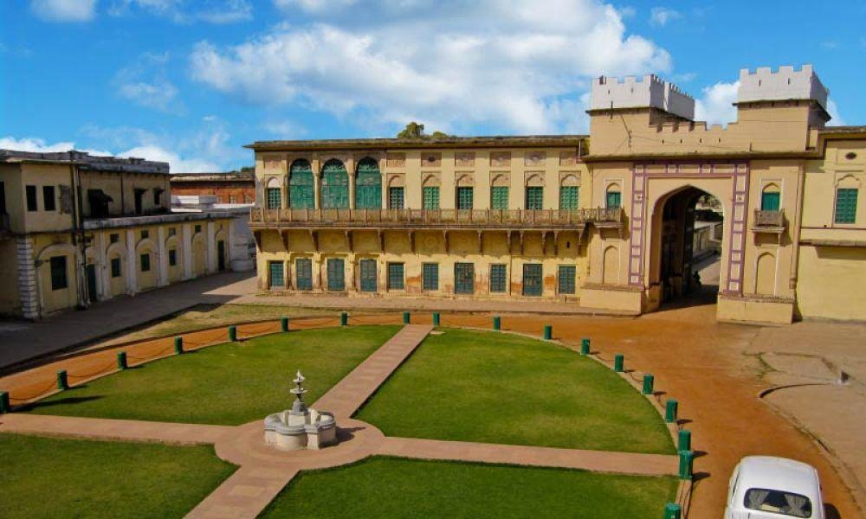
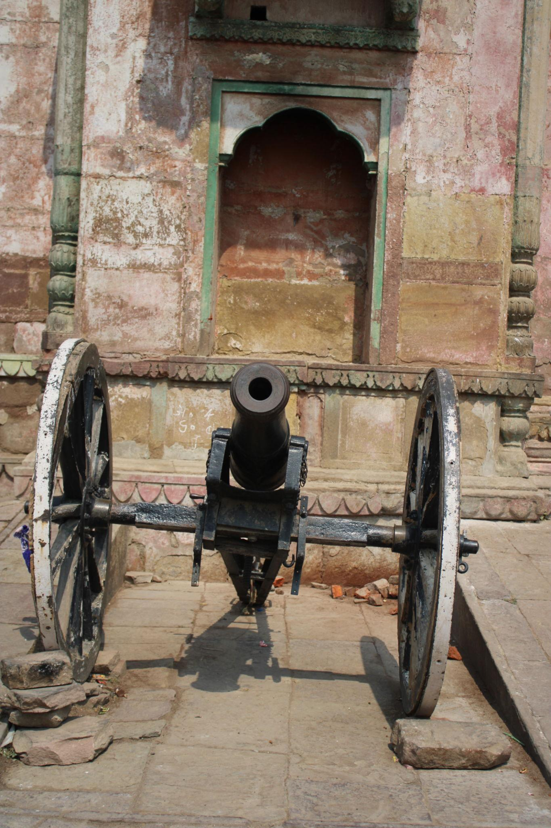
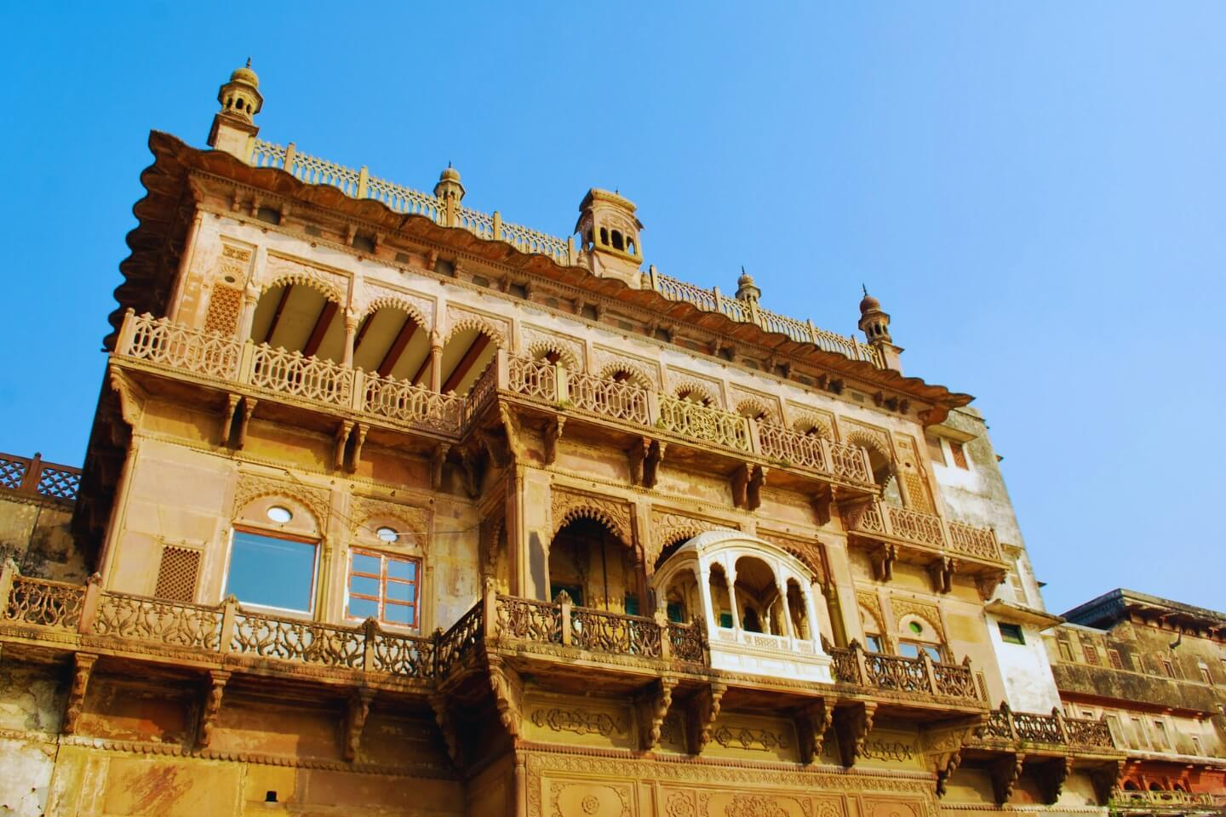
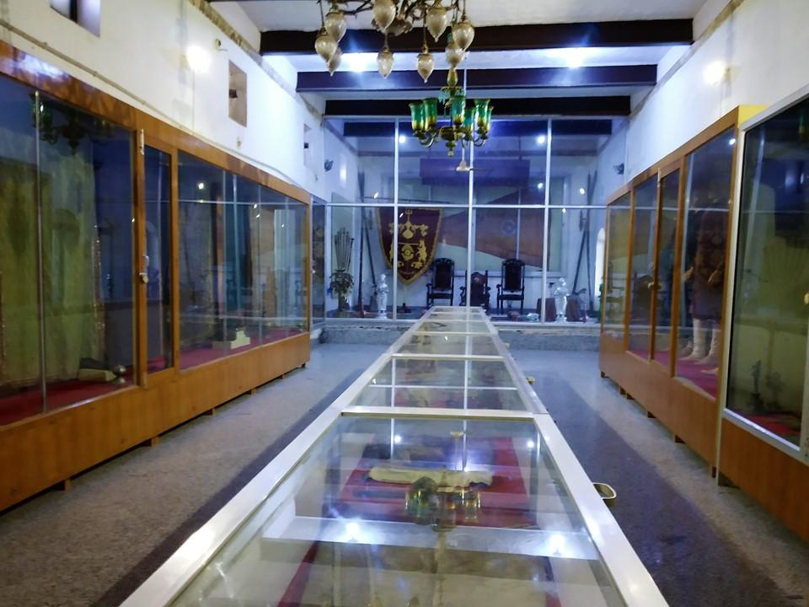
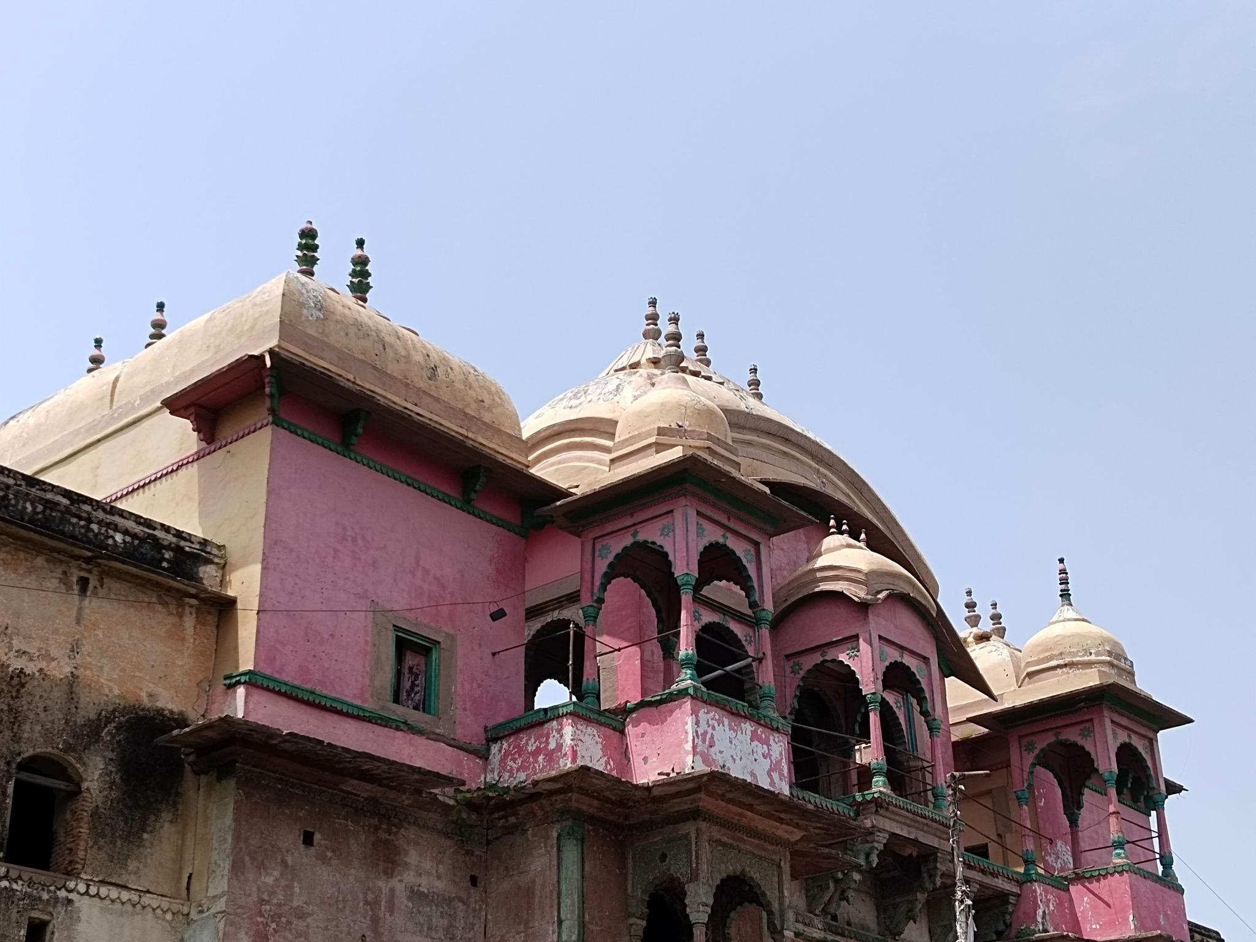
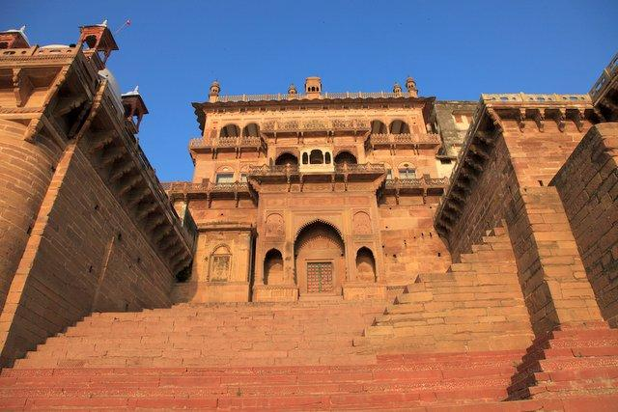

6. Manikarnika Ghat
One of the holiest cremation ghats in Hindu tradition, symbolizing the spiritual cycle of life and liberation.
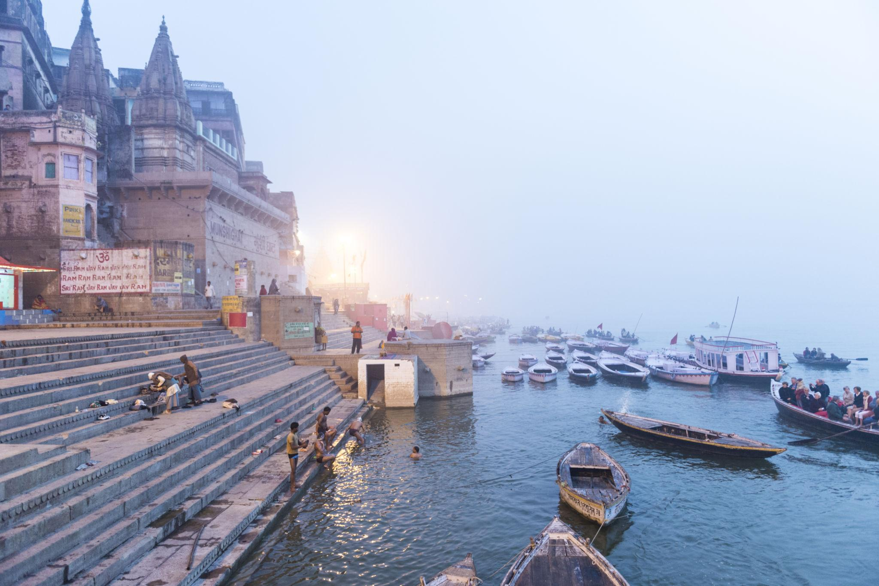
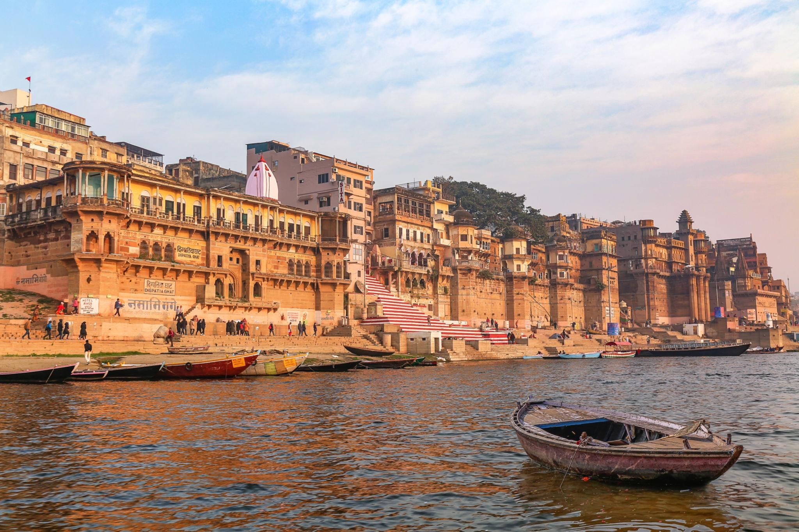
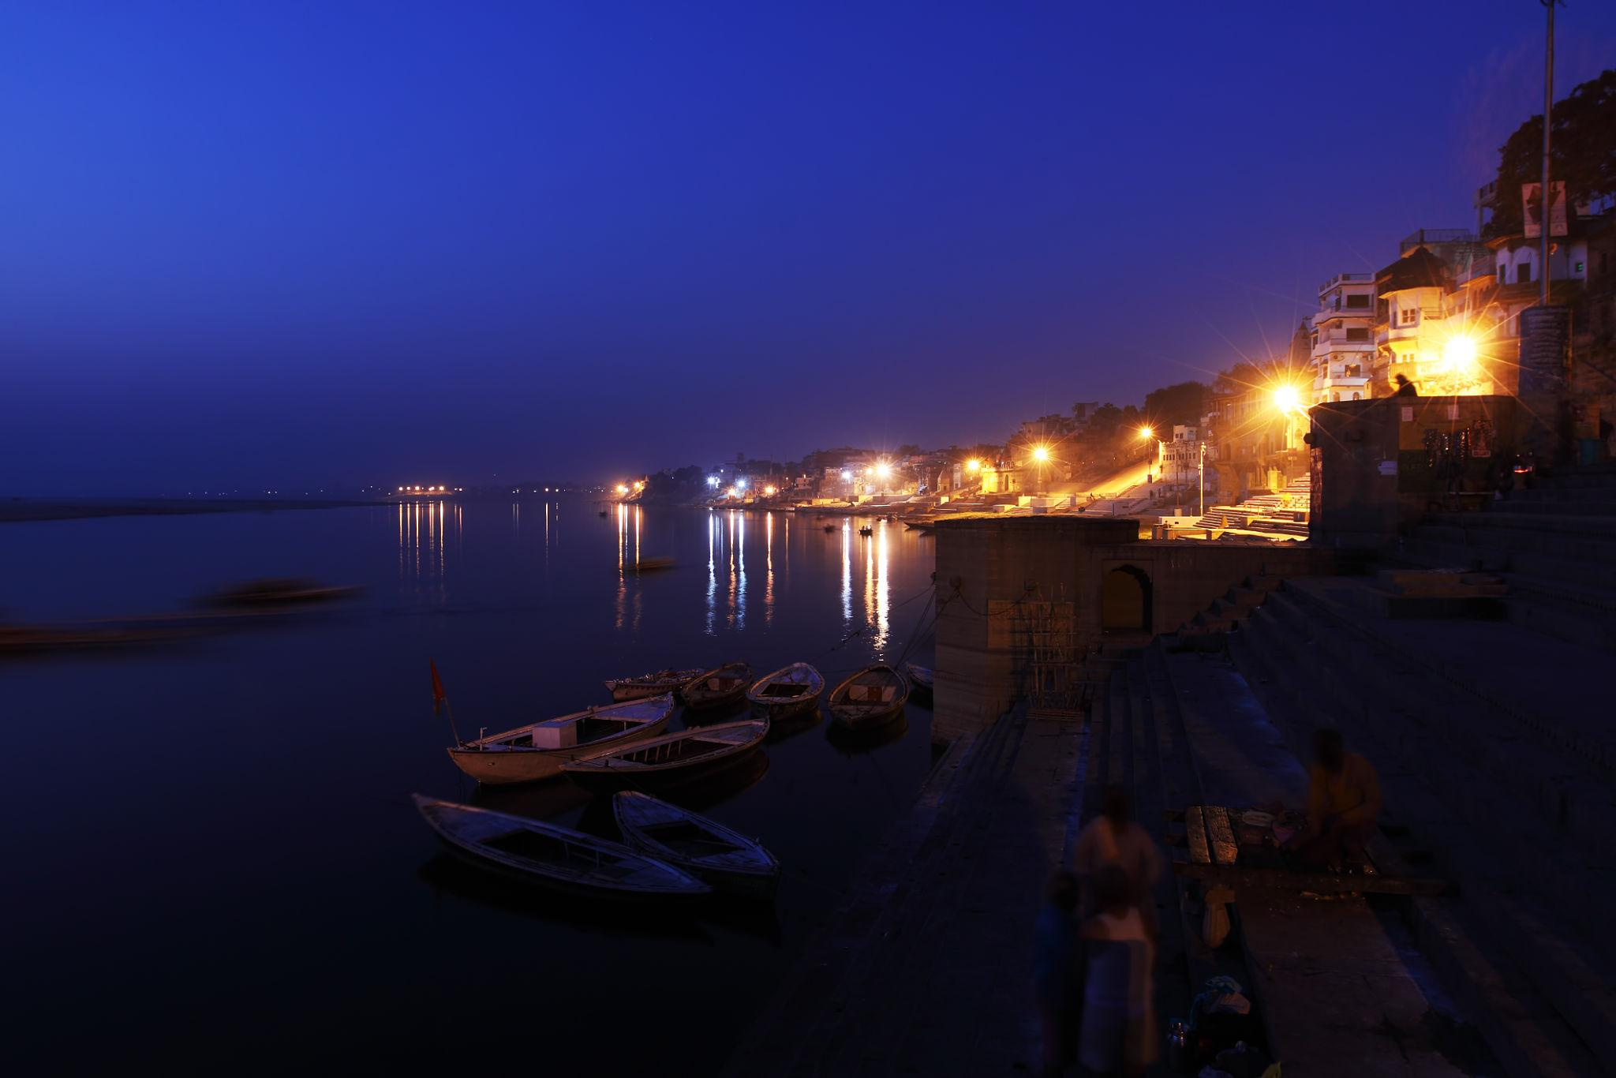
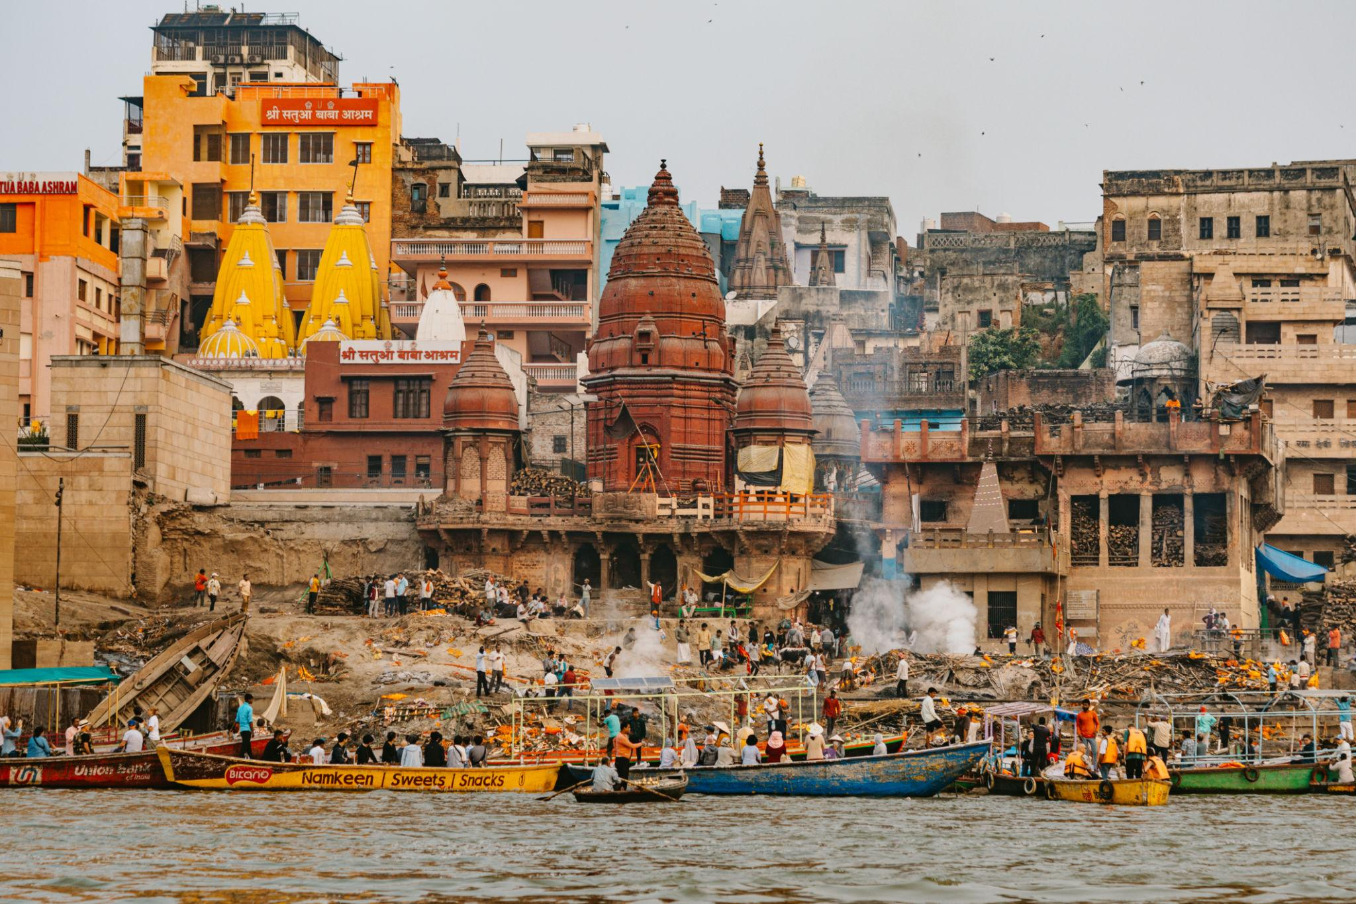
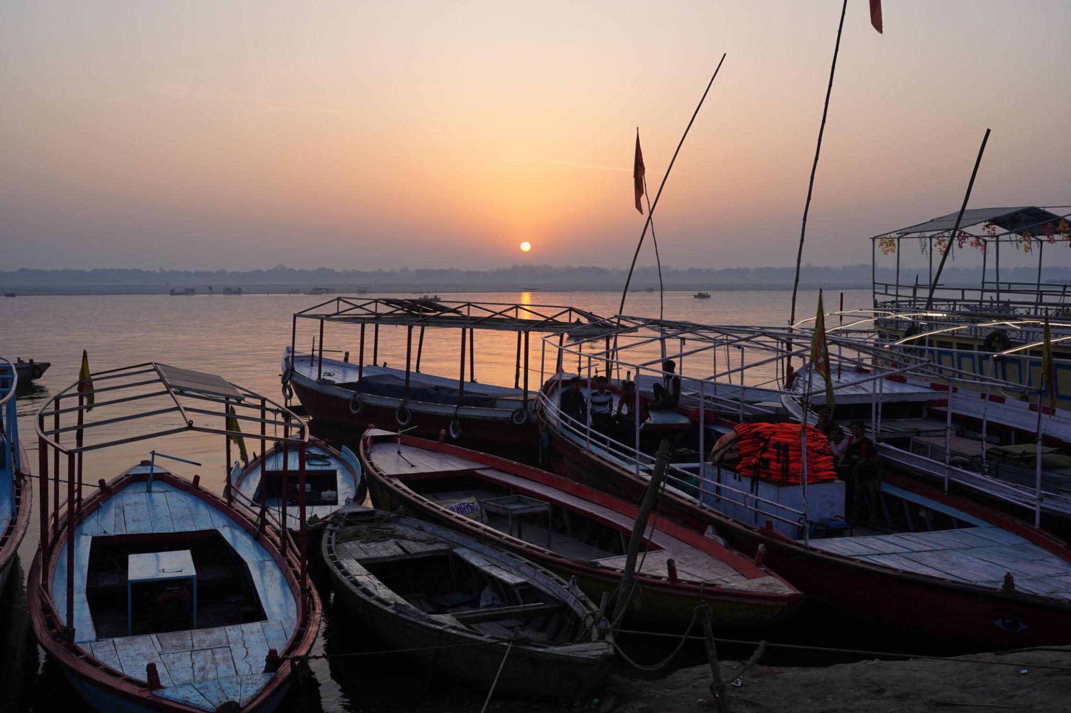
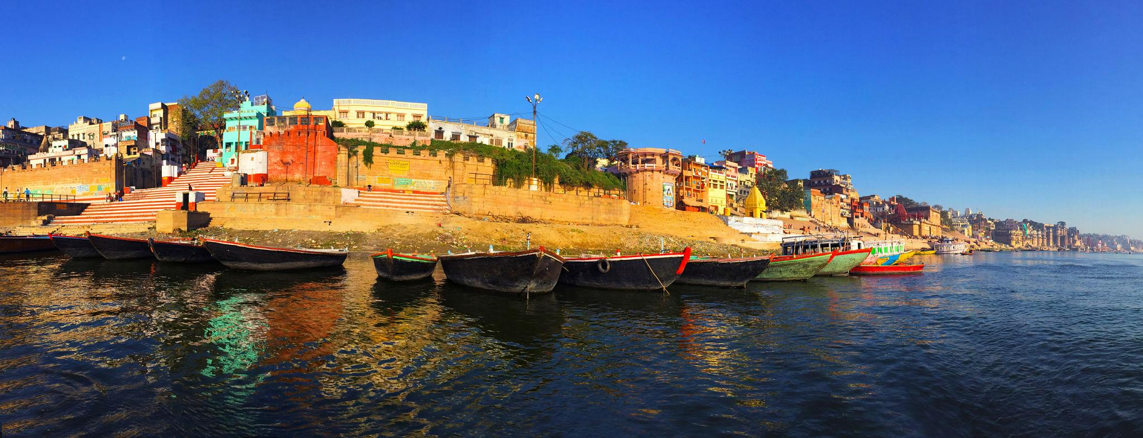
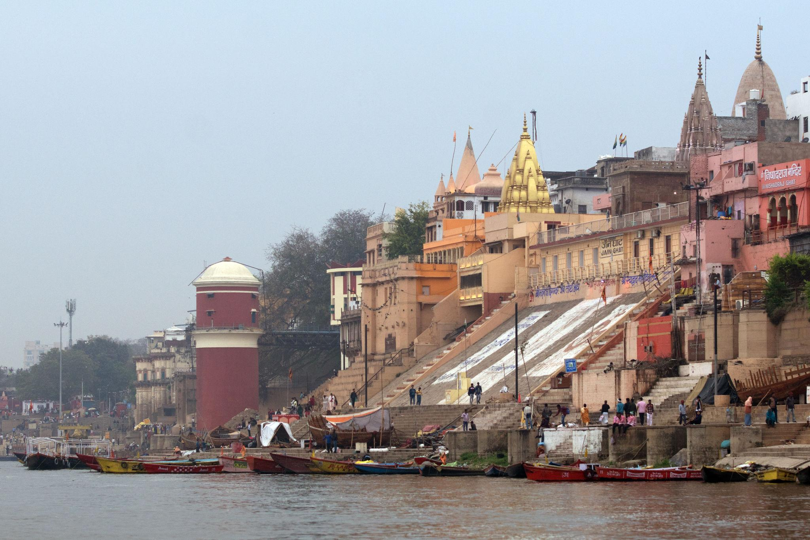

Best Things to Do in Varanasi
- Attend the evening Ganga Aarti
- Take sunrise boat rides on River Ganga
- Explore ancient temples & ghats
- Experience yoga & meditation
- Visit Sarnath Buddhist sites
- Explore narrow heritage lanes
- Shop for Banarasi silk sarees
- Taste authentic Banarasi street food
- Experience spiritual rituals & ceremonies

Famous Markets & Shopping in Varanasi 🛍️
Popular Shopping Places:
- Vishwanath Gali
- Godowlia Market
- Thatheri Bazaar
- Chowk Area
Famous items:
- Banarasi silk sarees
- Wooden handicrafts
- Brass items
- Spiritual souvenirs
- Traditional jewelry
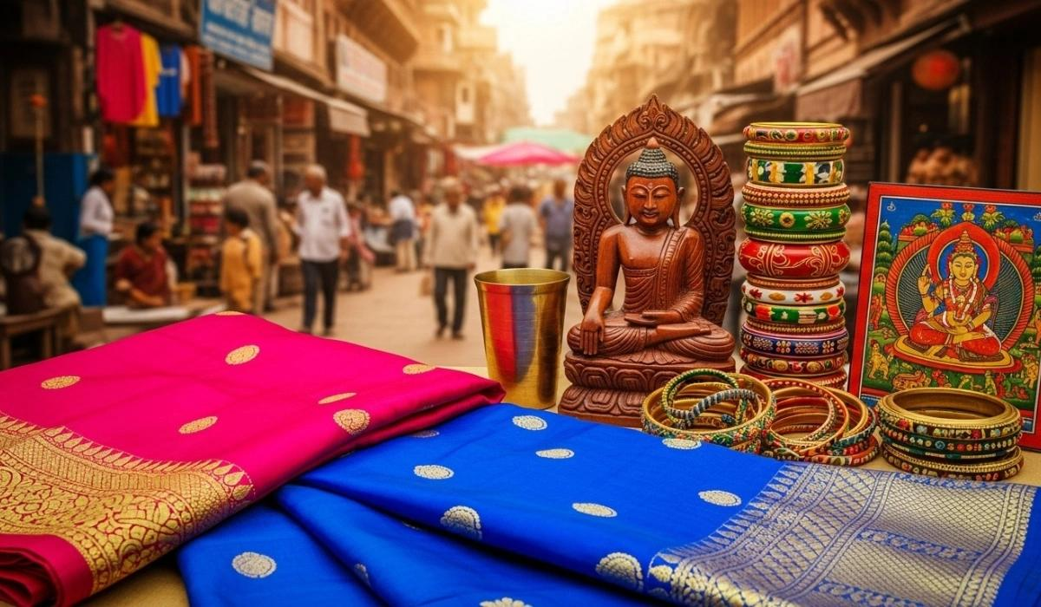
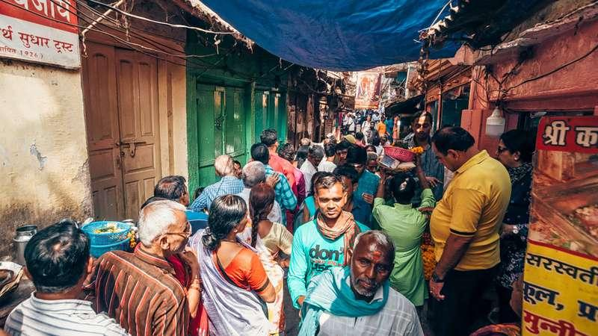
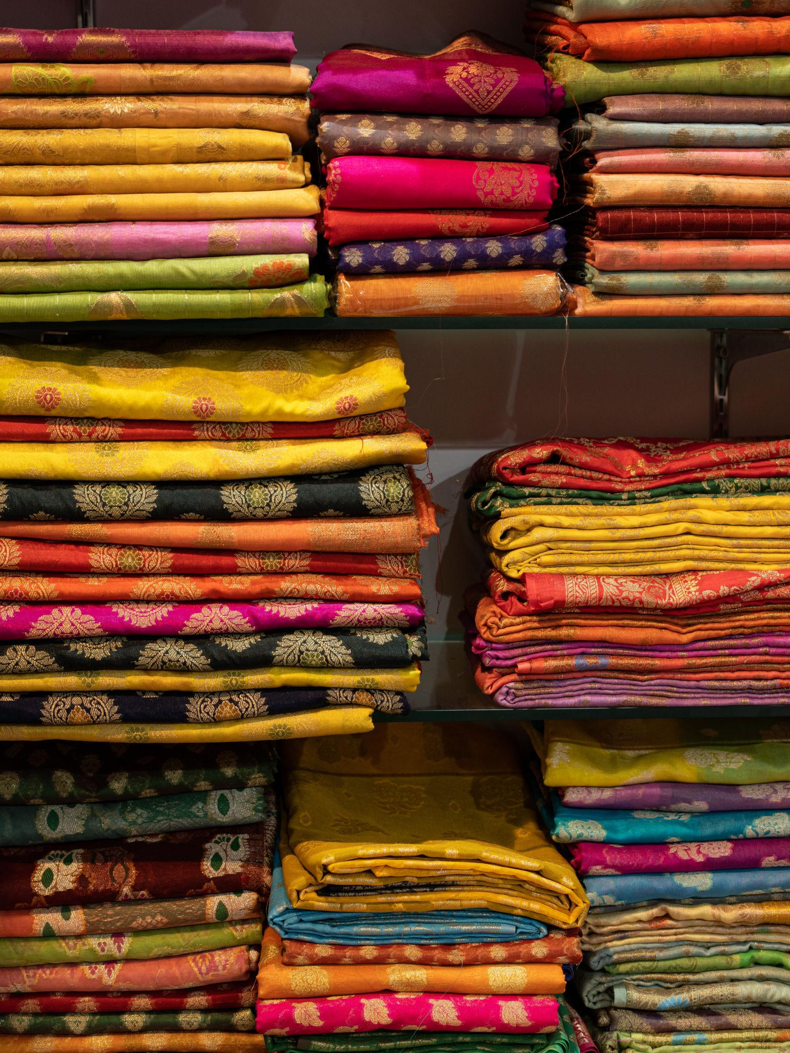
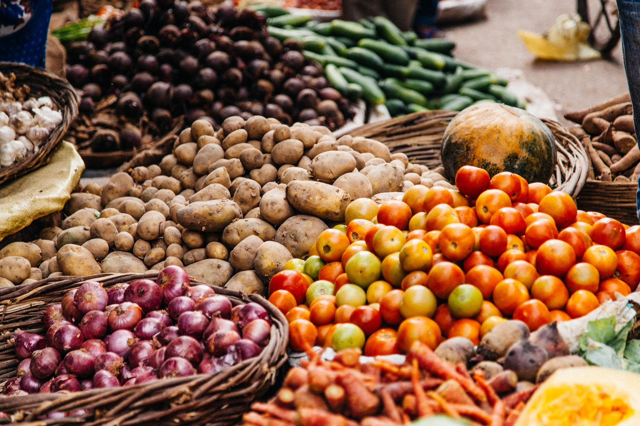
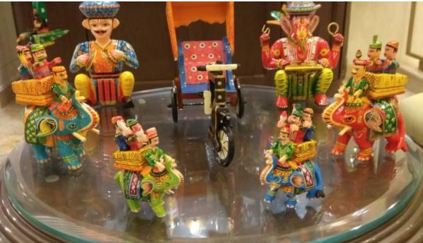
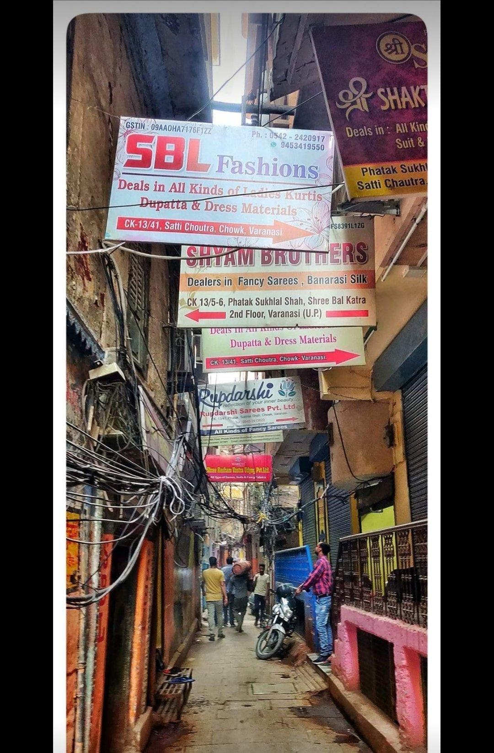

Best Time to Visit Varanasi
Season | Months | Weather
Winter | October – March | Pleasant & best for sightseeing
Summer | April – June | Hot
Monsoon | July – September | Moderate rainfall
Winter is the best season to visit Varanasi.

How to Reach Varanasi
By Air
Main airport:
- Lal Bahadur Shastri International Airport
By Train
Varanasi is well connected with:
- Delhi
- Kolkata
- Mumbai
- Lucknow
- Patna
By Road
Excellent road connectivity from major North Indian cities.

Famous Foods to Try in Varanasi 🍴
- Banarasi Paan
- Kachori Sabzi
- Tamatar Chaat
- Malaiyyo
- Lassi
- Jalebi
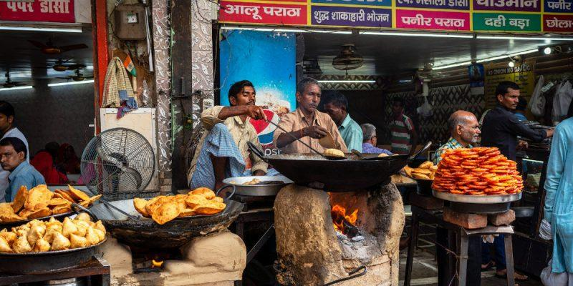
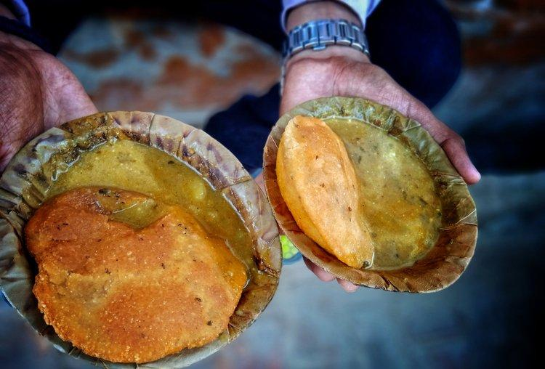
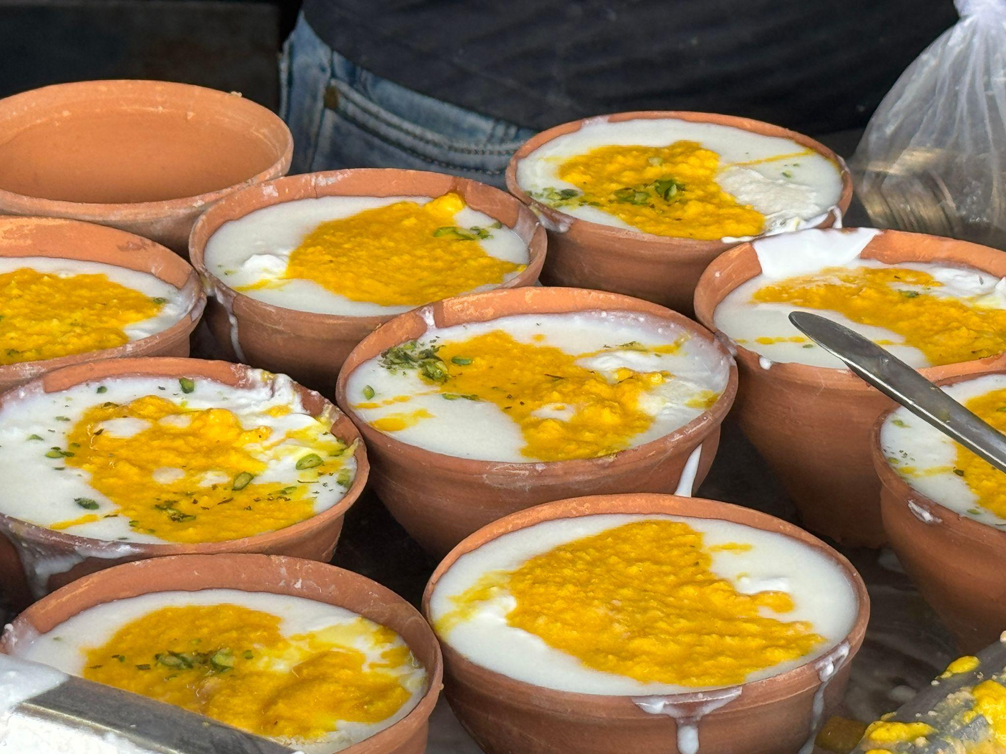
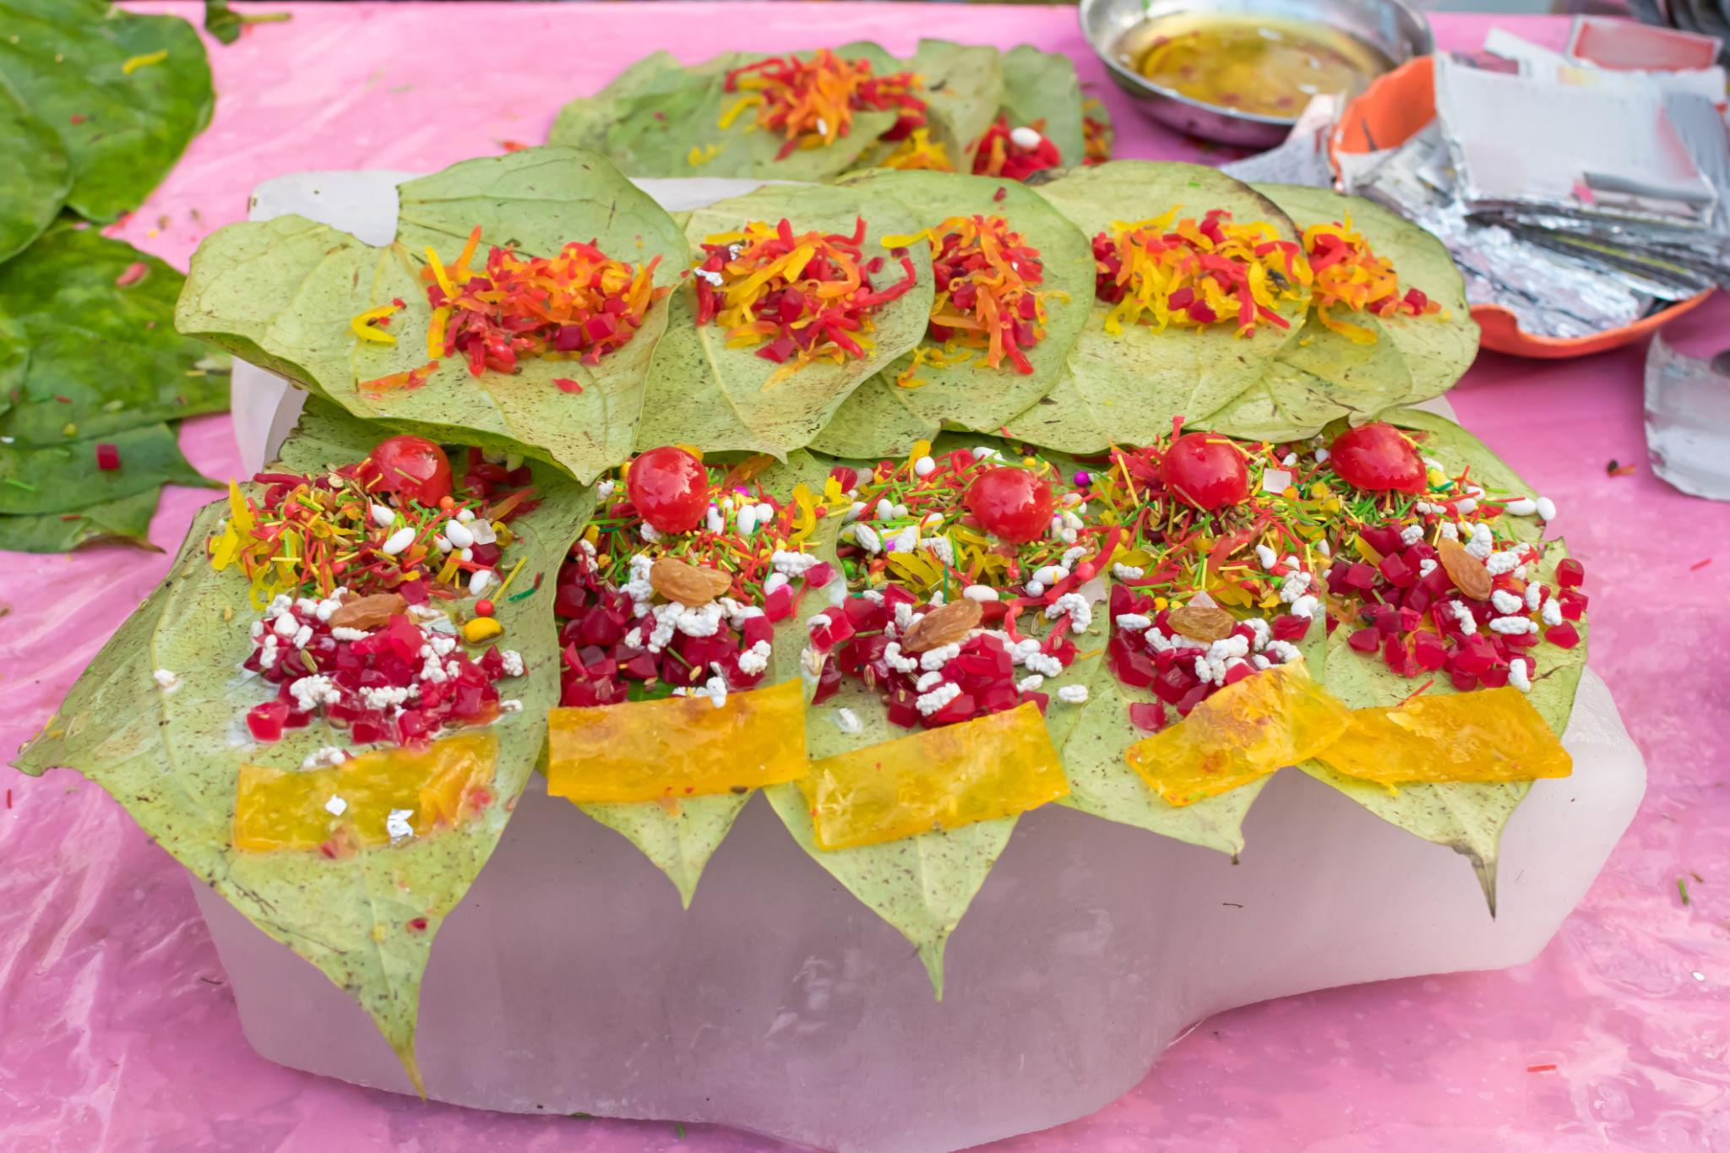
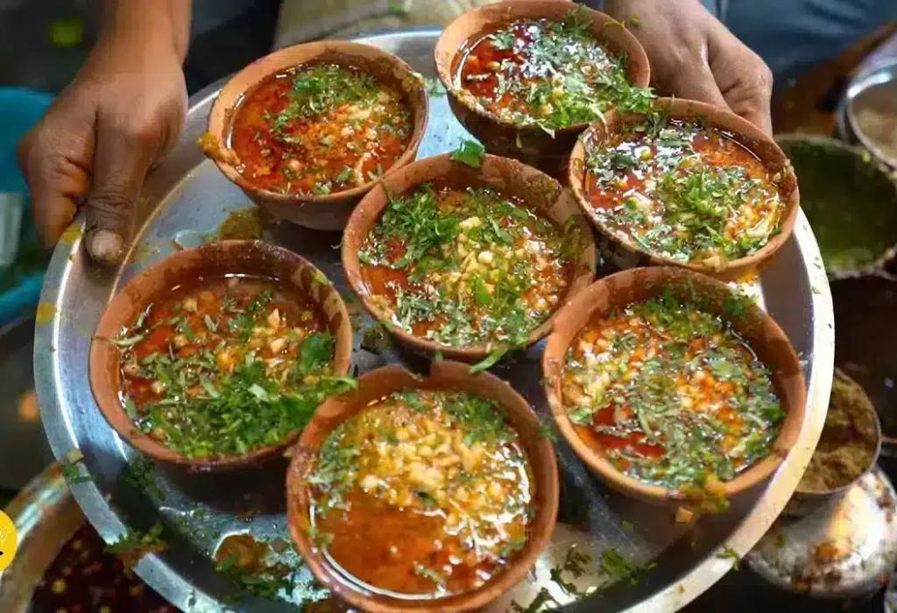

Luxury Experiences in Varanasi ✨
- Luxury riverfront stays
- Private Ganga boat cruises
- Spiritual wellness retreats
- Heritage walking tours
- Fine dining with Ganga views
- Personalized temple tours
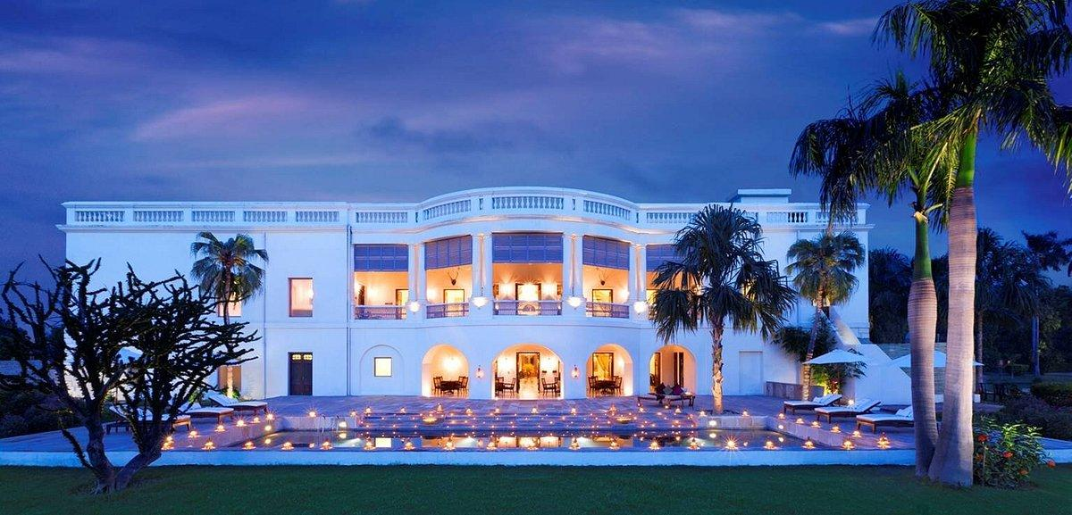
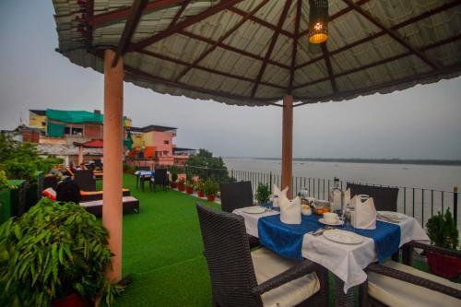
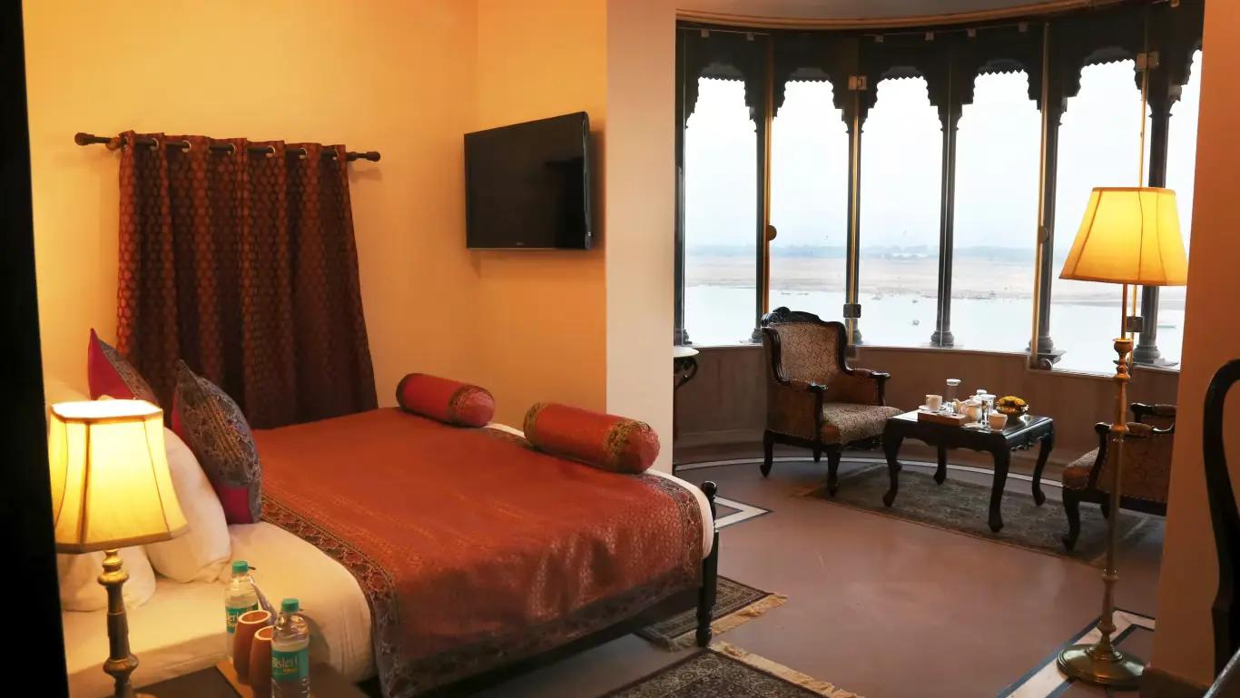

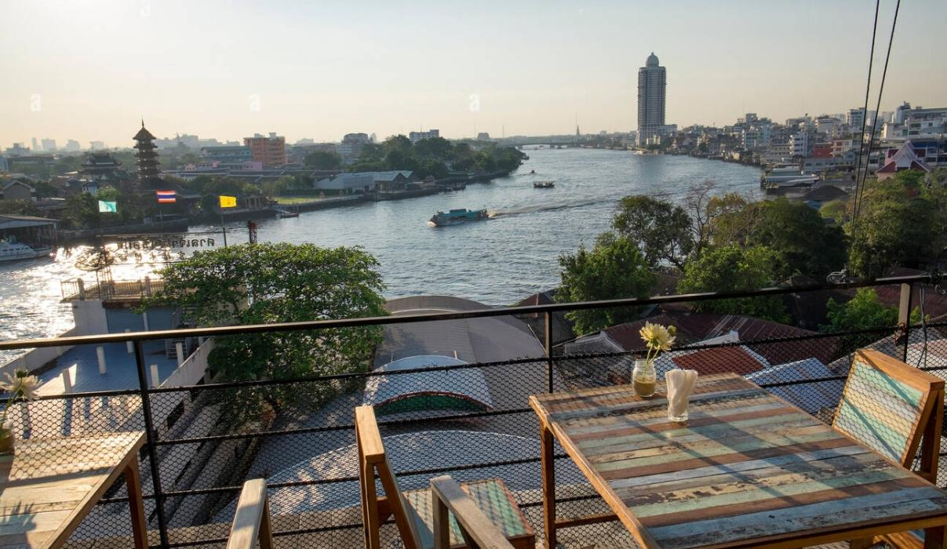
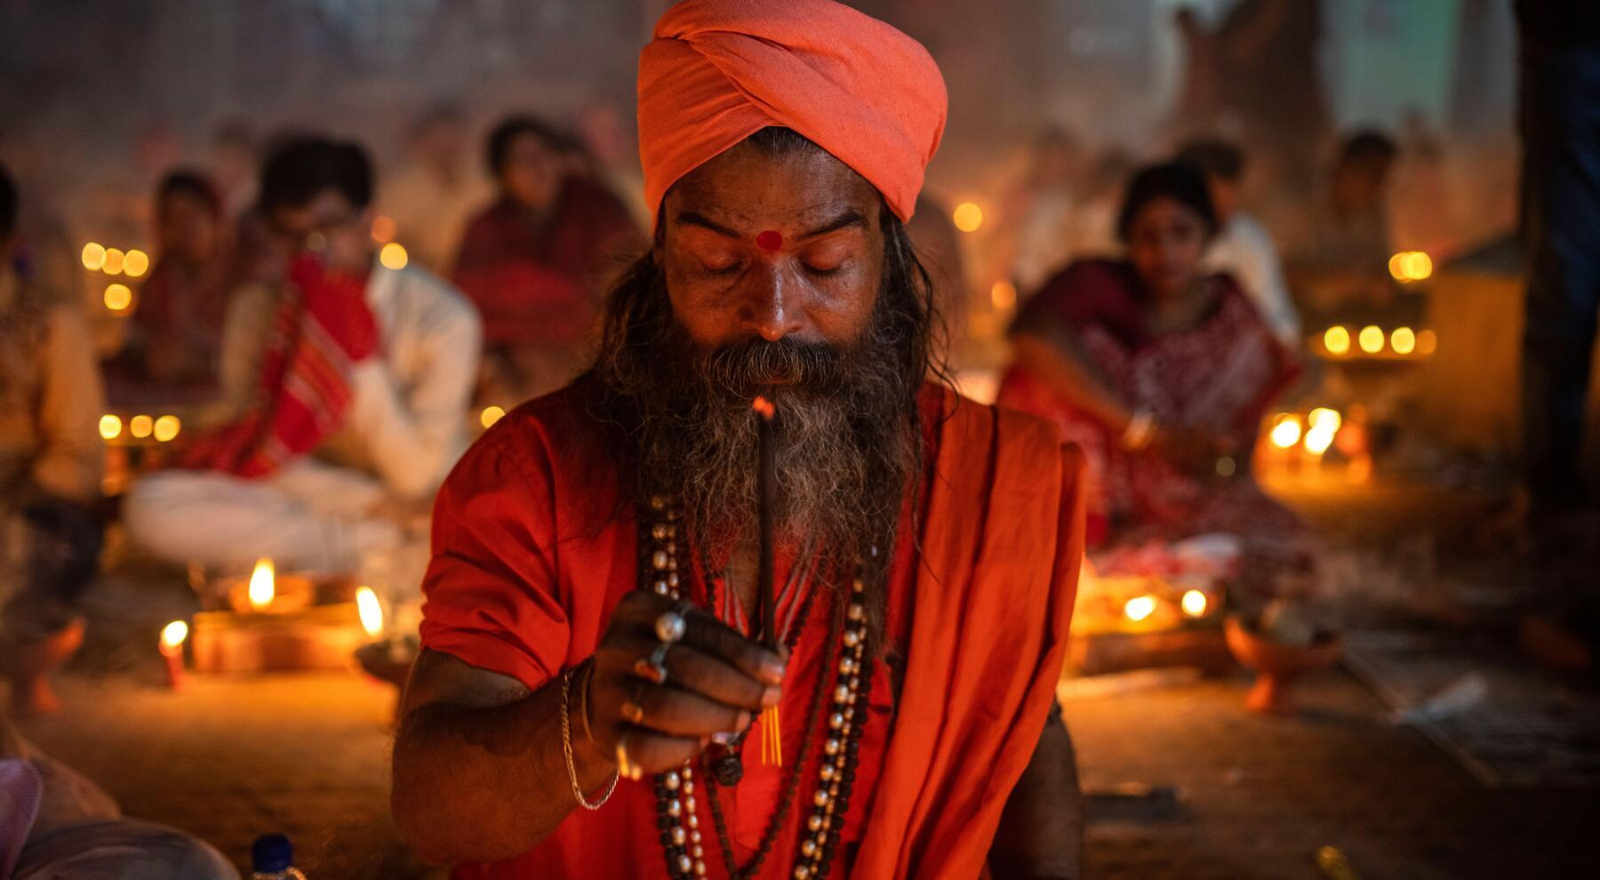

Varanasi Travel Tips
- Dress modestly while visiting temples
- Visit ghats early morning for best experience
- Carry comfortable footwear
- Respect religious customs & rituals
- Keep valuables secure in crowded areas
- Hire licensed local guides for heritage tours

Why Choose INTRO TRAVELS INDIA for Varanasi?
With INTRO TRAVELS INDIA, you get:
- Customized Varanasi tour packages
- Spiritual & heritage tours
- Comfortable hotel accommodations
- Guided temple & ghat tours
- Airport & railway transfers
- Family & group travel packages
- Cultural & food experiences
- Private boat ride arrangements
Varanasi is a destination where spirituality, ancient traditions, sacred rituals, cultural heritage, and timeless beauty come together to create one of India’s most extraordinary travel experiences.

